**Gender Sensitization Action Plan**

**“If you educate a man you educate an Individual, however If you educate a woman you educate a whole family. Women empowered means Mother India Empowered”** Pt. Jawaharlal Nehru.

This is very true and it requires collective efforts to make this true.

**Academic Year 2021-2022**

|  |  |  |
| --- | --- | --- |
| Topic | Date | No. of participants |
| Beti Bachao beti Padhao | 1.12.2021 | 35 |
| Constitutional rights | 28.2.2022 | 45 |
| Elocution competition, Debate | 4.3.2022 | 120 |
| International Women’s Day | 8.3.2022 | 87 |
| Adopt A Plant | 9.3.2022 | 37 |
| Awareness on Health and Hygiene | 19.3.2022 | 30 |

**1.Beti Bachao Beti Padhao**

In 2015 Indian Government introduced the Beti Bachao Beti Padhao scheme to address concern of gender discrimination and women empowerment in the country. This name translates the Save the Girl child, Educate the Girl Child. The scheme aims to educate citizens against gender based and improve Beti Bachao beti Padhao efficiency of welfare services for girls. It was launched with an initial founding of 100 crores.

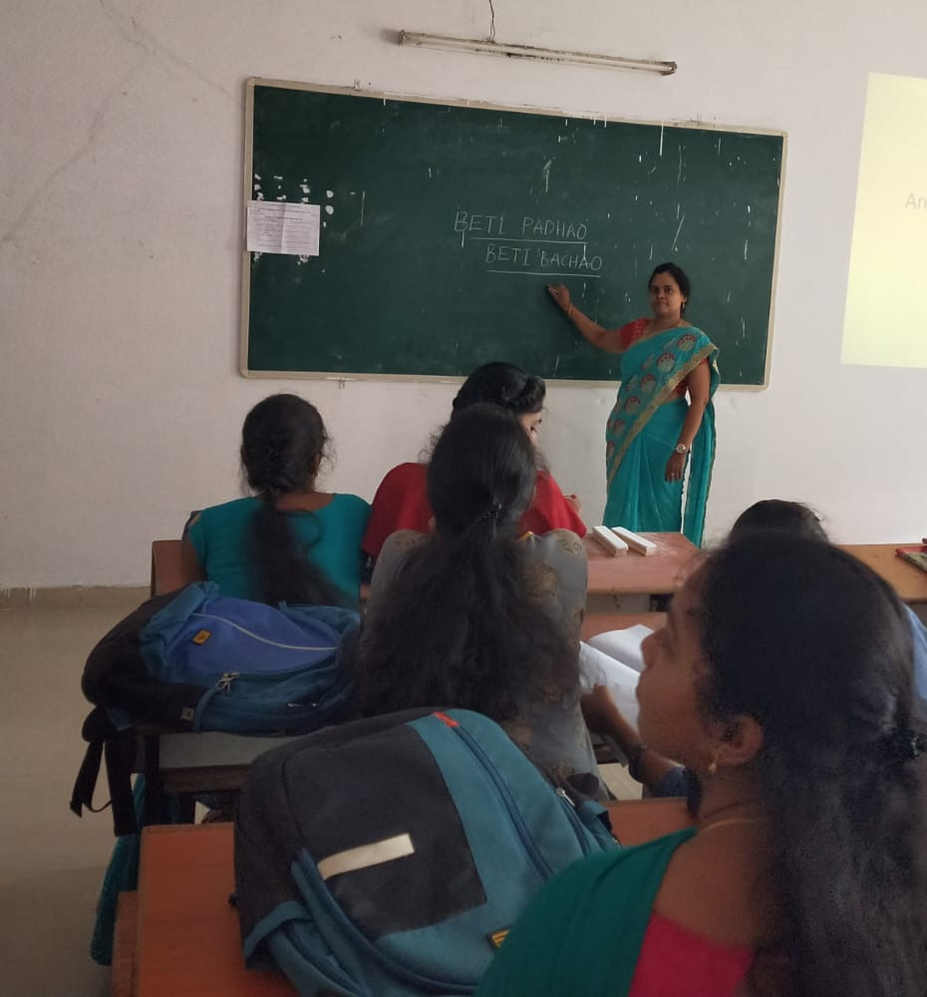

Beti bachao Beti Padhao A Motivational talk by- Smt J. Sandhya

**2.Constitutional Rights: Right to Education**

The constitution Act 2002 inserted article 21-A in the constitution of India to provide free and compulsory education of all children in the age group of 6-14 years as a fundamental right. The act provides for the right of free and compulsory education to children until they complete their elementary education in a school in the neighbourhood. It promotes Individaul freedom and empowerment and yields important development benefits.

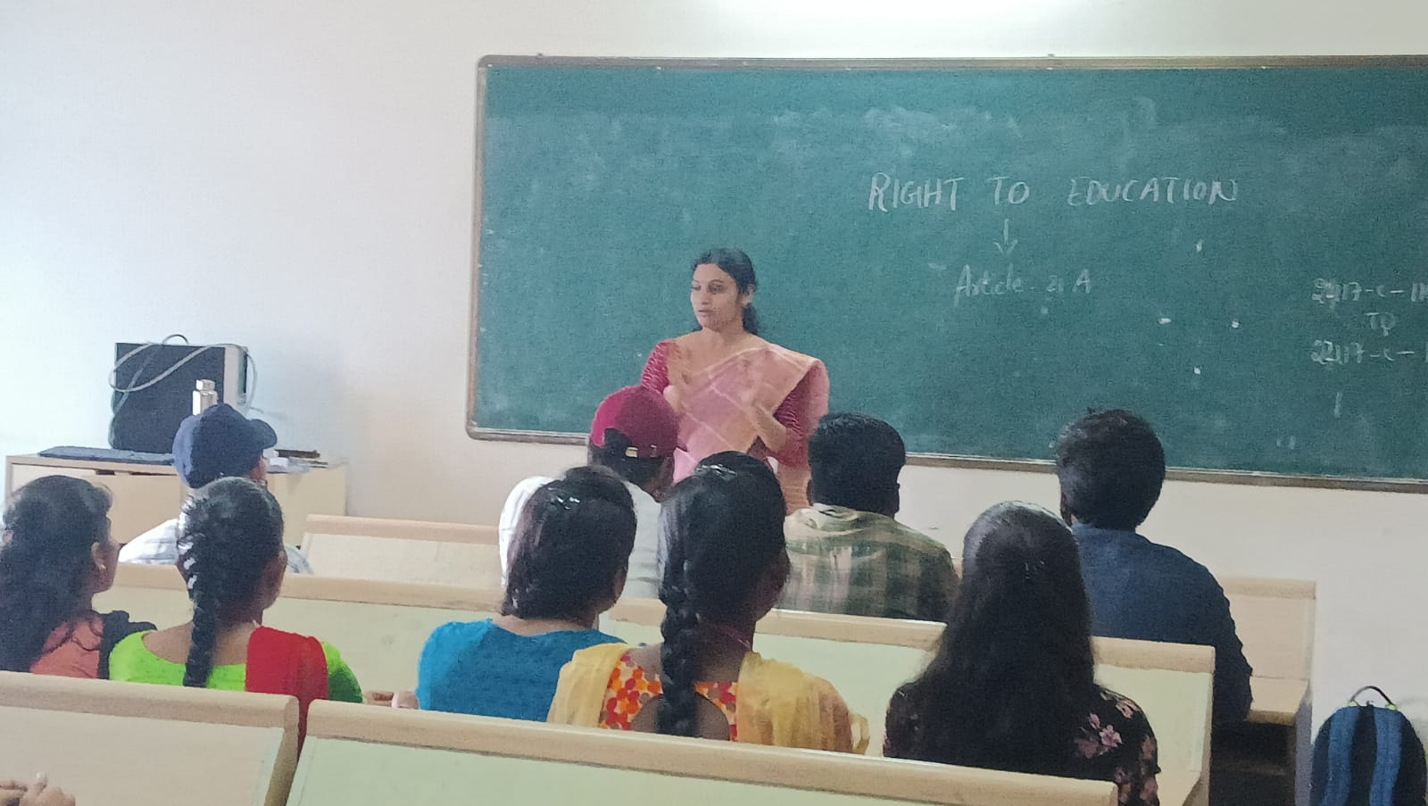

Right to Education An Awareness by- Smt T. Anusha

Group Discussion was conducted on the constitutional awareness which was created among students. They discussed regarding the issues concerning women.

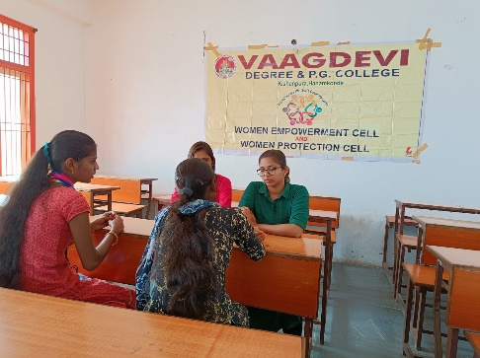 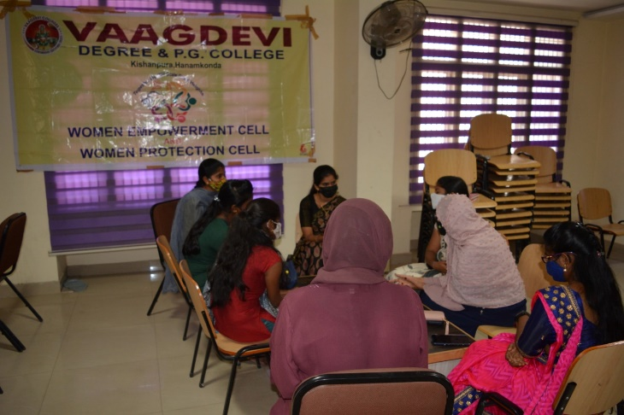

Group discussion on Child Marriage

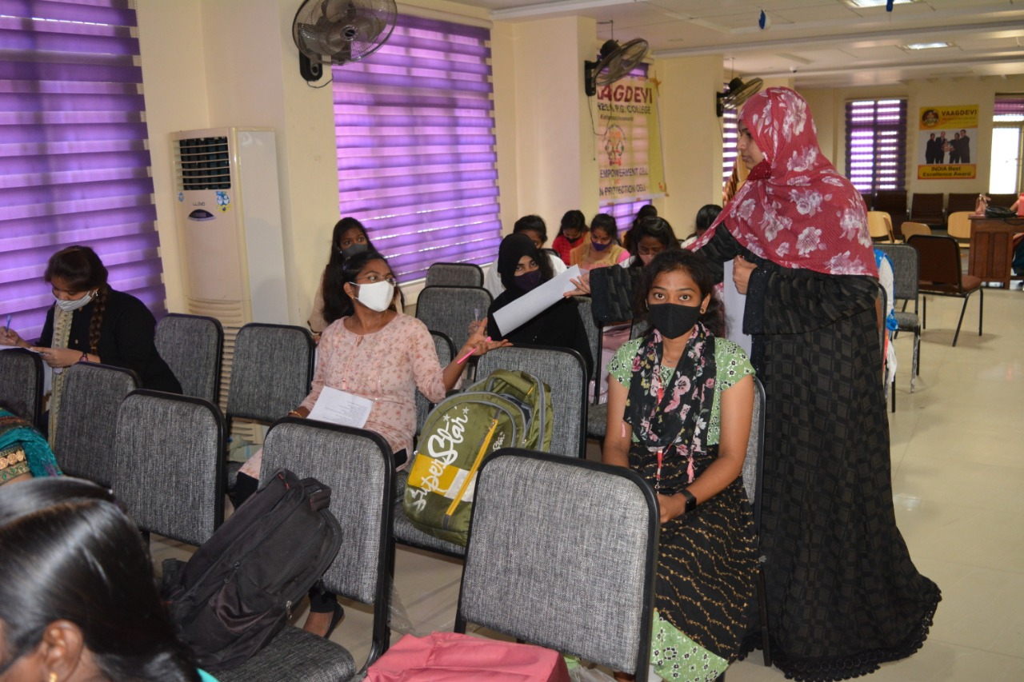

Quiz competition regarding constitutional awareness created by Smt T. Anusha.

**3. Debate and Elocution compettion on 4.3.2022**

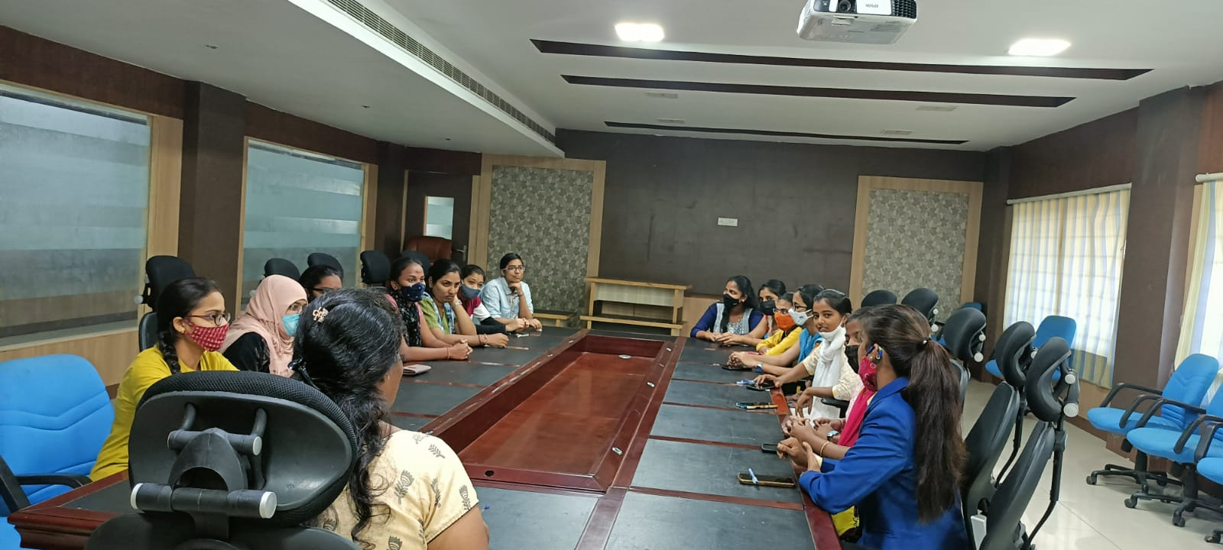

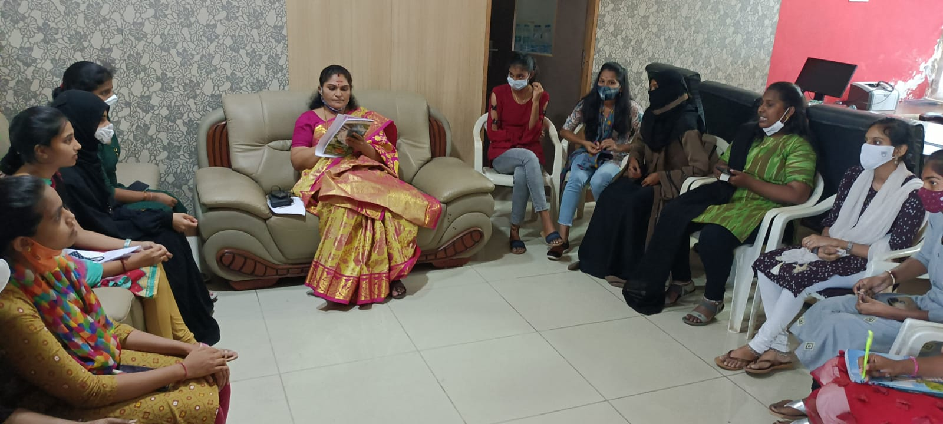

I round debate to shortlist finalists. Is 33% reservation necessary for women

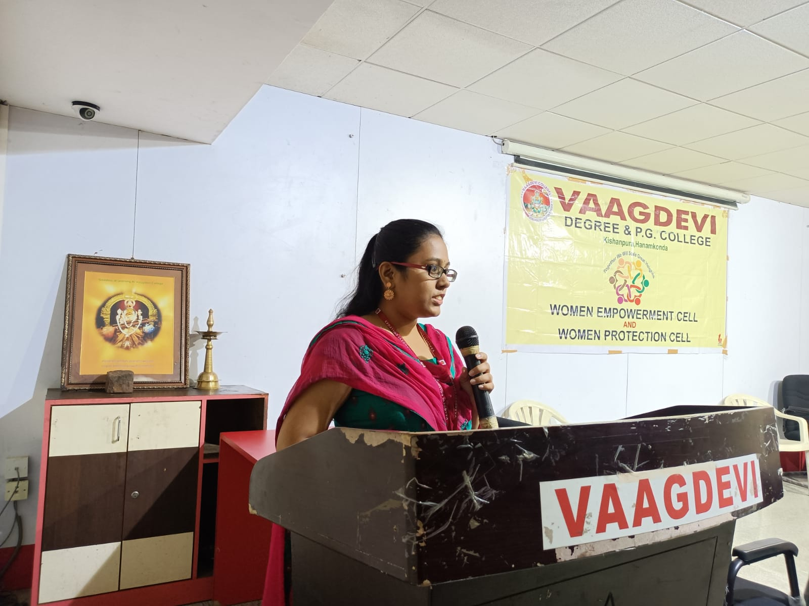

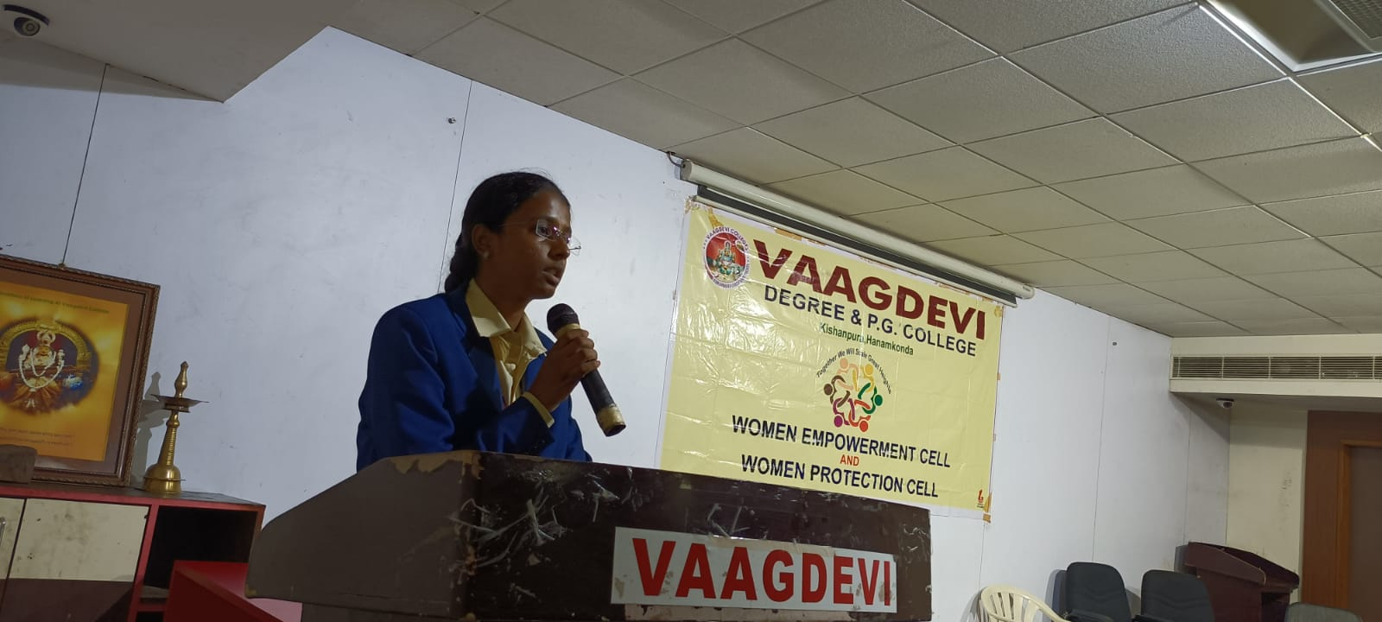

Elocution Competition ‘Economic Independence of women’

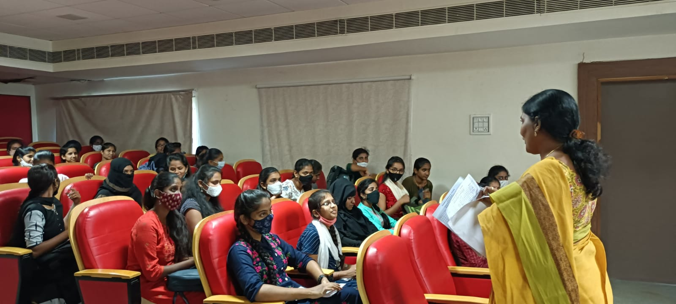

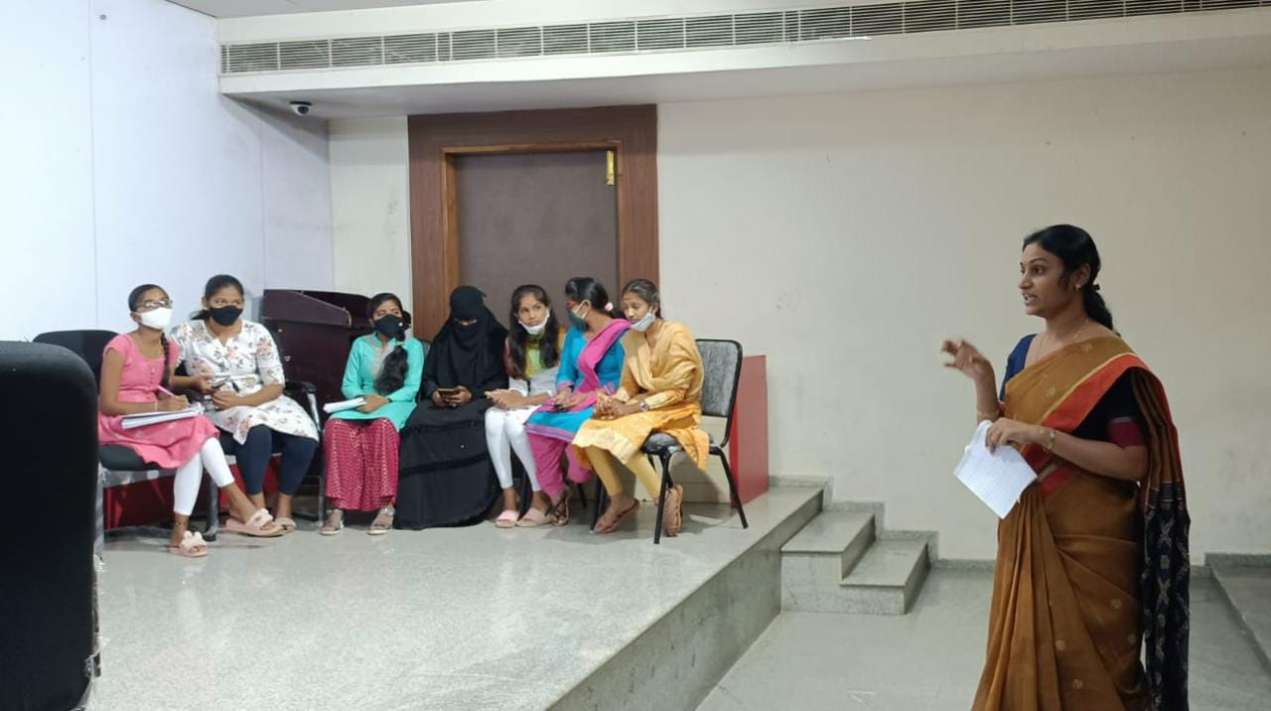II round Debate Competition- Is Women Empowerment Necessary

**4.International Women’s Day 2022:**

Post Covid women’s Day celebrations were conducted involving the students who were present in the campus. The students were able to participate in the competitions organized and win prizes. The students performed on women’s day making the event colorful. All the women in the campus including Teaching, Non Teaching, Class Iv, students made the program cherishable.

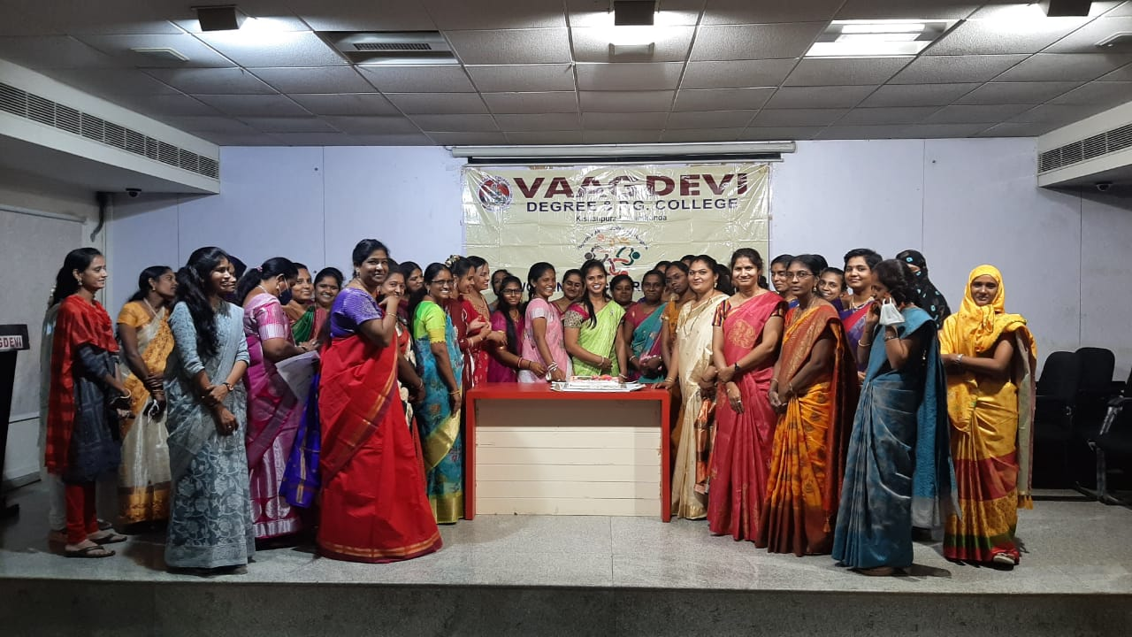

**Student Performances On occasion of Women’s day**

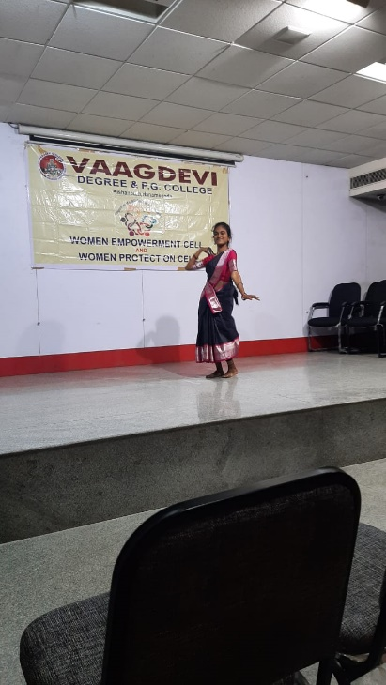

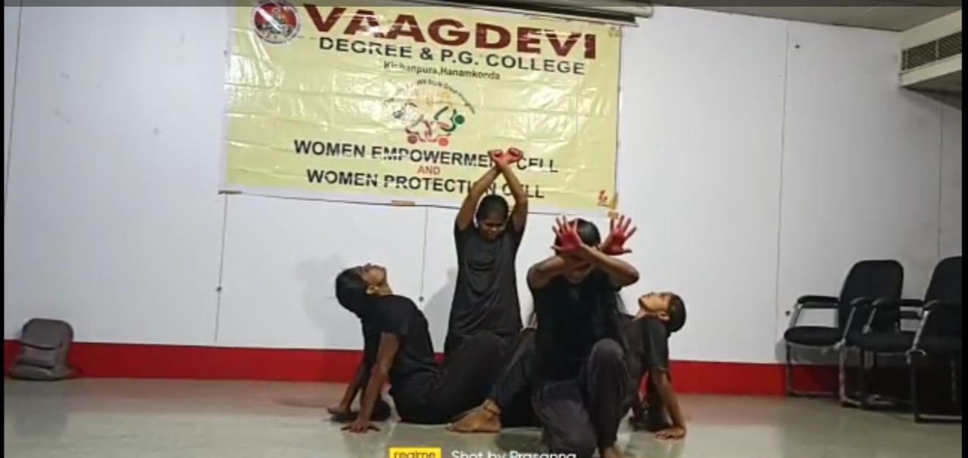

MBA students performing concept oriented Dance

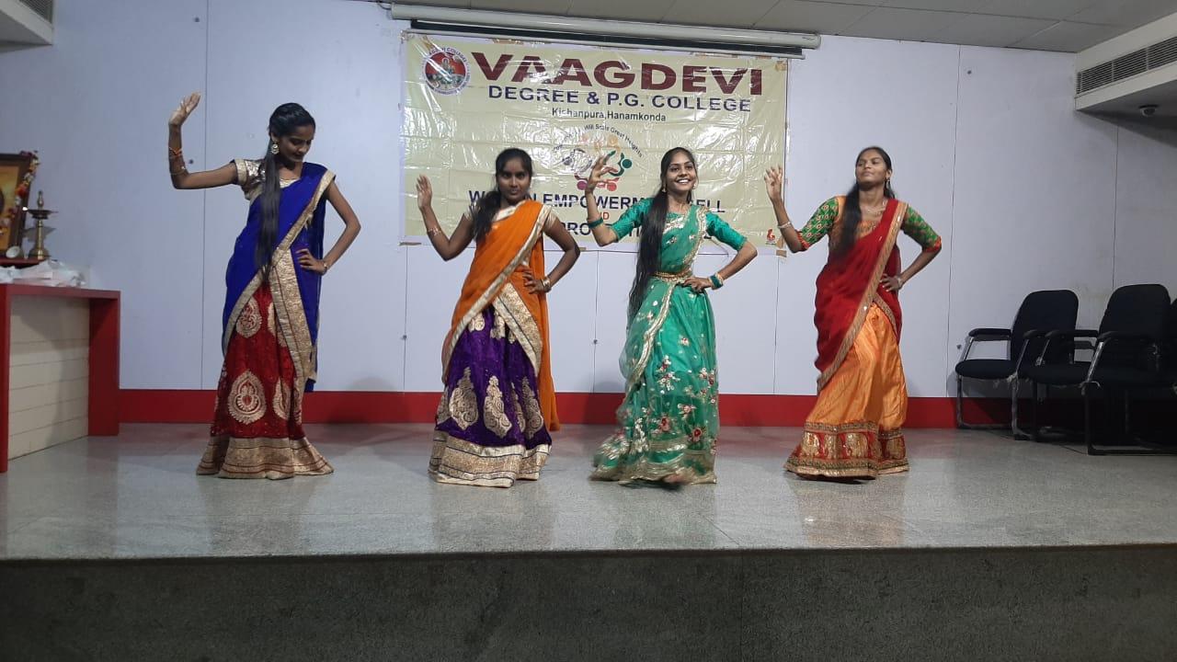

MSc Zoology students performing dance

**Woman rights, woman protection poster by student**

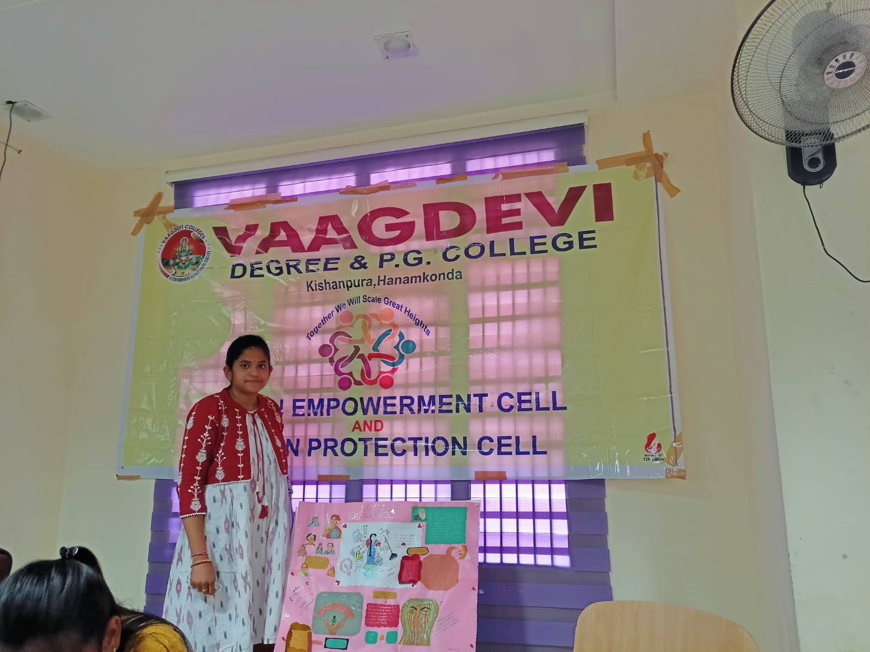

Prize distribution to winners on Occasion of women’s day for various competitions organised

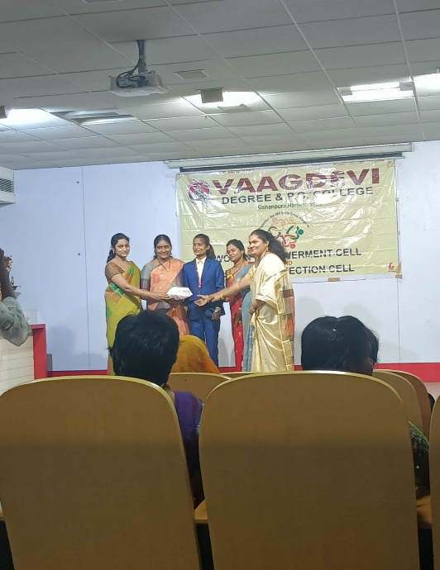

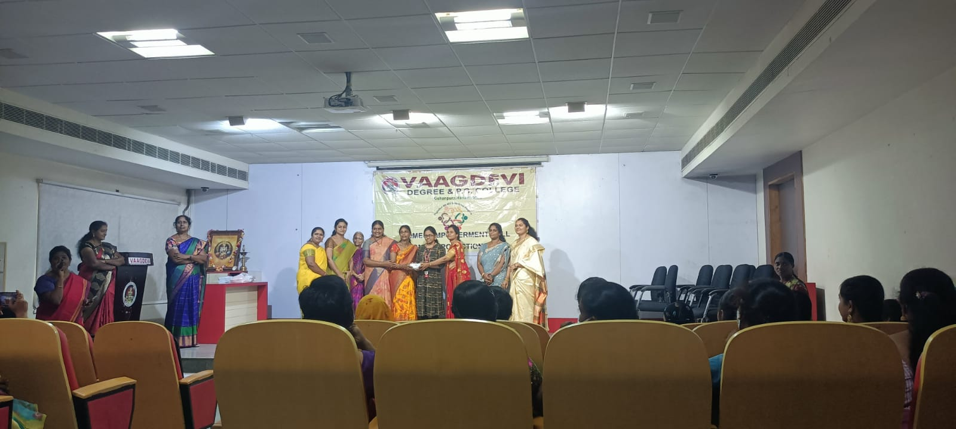

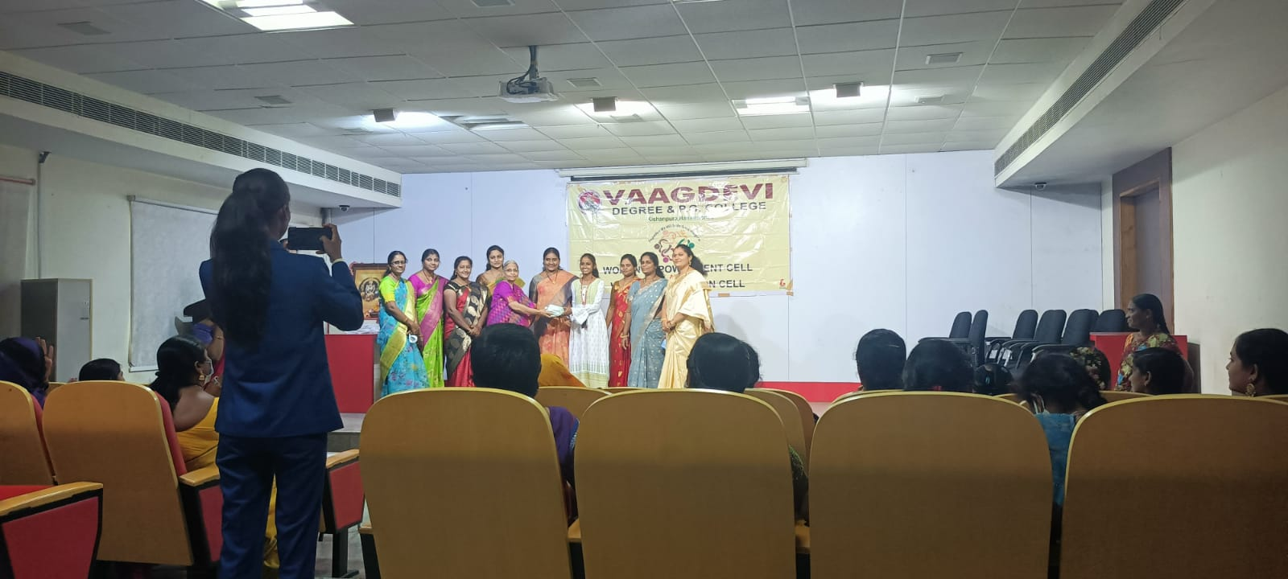

**5. Adopt A Plant:**

To ensure that the campus remains carbon neutral, we have been trying to balance the ecosystem by taking up plantation programs and encouraging the staff by starting **‘Adopt a Plant’** to save the plants.

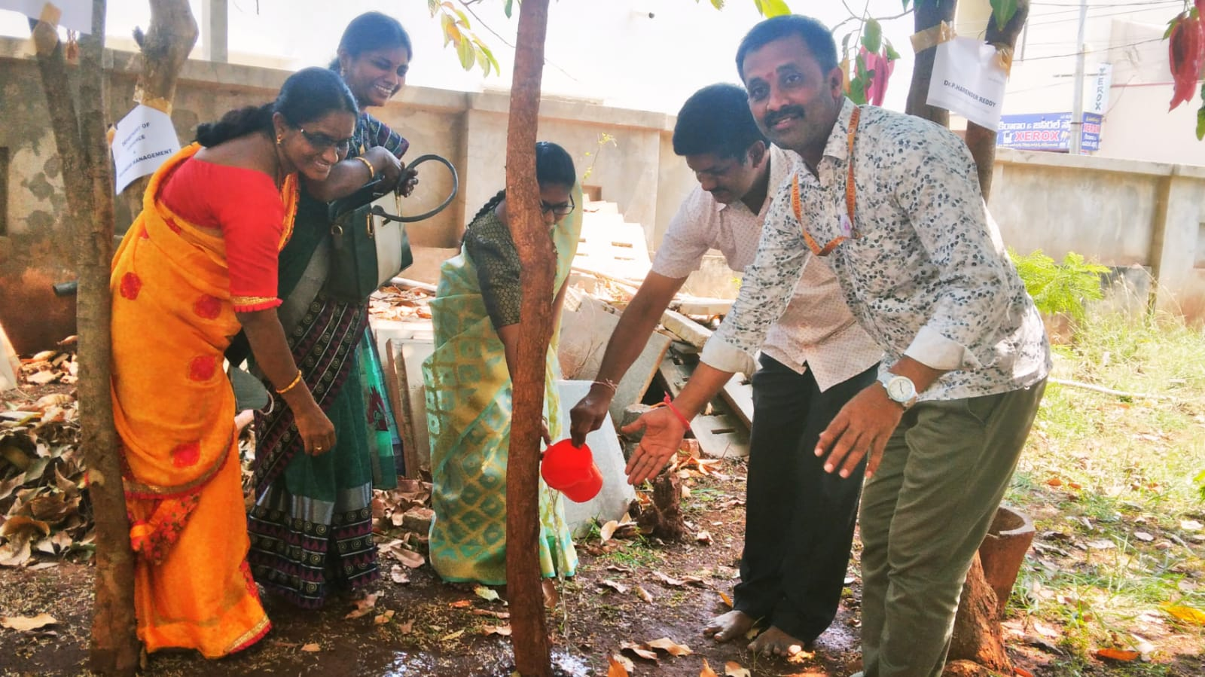

Adopted Plant of Department of Botany

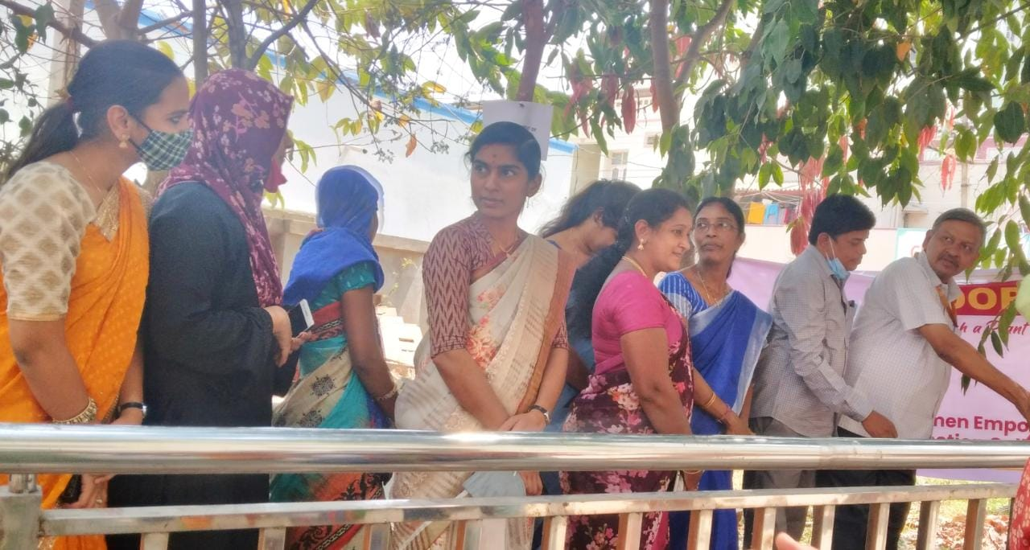

Adopted Plant of Department of Chemistry

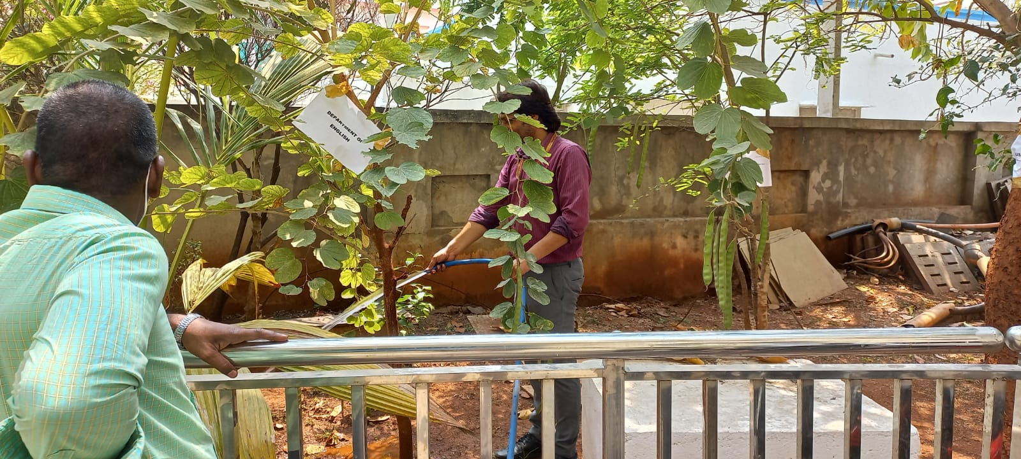

**Maintaining the plant-Department of Computers.**

**5.Awareness on Health & Hygiene**

Dr. Chandrakala created an awareness on Health and hygiene which are interrelated to each other and anyone should learn to take a lot of care.. Hygiene is of paramount importance especially to women, since it is directly related to health issues. Any negligence on hygiene is resulting in a number of diseases. Typhoid, cholera, dysentery amoebiasis are a result of nonhygienic conditions. It is important to know that totally we have a number of other diseases too. Urinary tract infection, Pneumonia, skin diseases can also result. Continuous exposure to water can result in these diseases. In men they develop a habit of smoking, liquor, taking drugs and become addicts. As a result of all these they also begin to neglect their hygiene which is extremely detrimental.

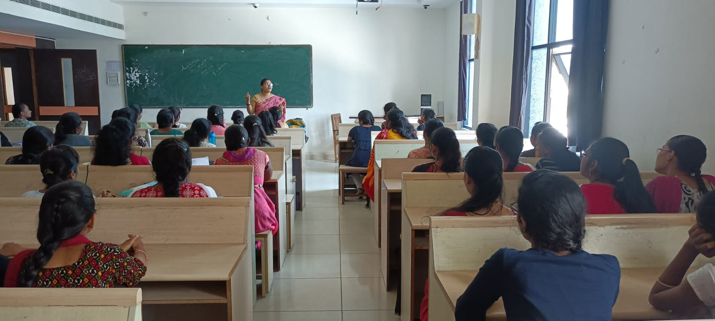

Dr. Chandrakala creating awareness on Health & Hygiene

**Academic Year 2020-2021**

|  |  |  |
| --- | --- | --- |
| Topic | Date | No. of participants |
| International Women’s Day | 8.3.2021 | 87 |
| Challenges faced by women in 21st century | 9.3.2021 | 37 |

International women’s day is celebrated every year on 8th of March. This is to honour the social, economic, cultural achievements of women from all spheres of life. It also recognizes the challenges and focuses greater attention on women’s rights and genders. It is a day of self-introspection and encouraging others around us. In the college the students, faculty, non teaching staff, all of them join in celebrating this occasion together. It is a day every female faculty looks forward to. Female achievers are felicitated on this day in recognition of their achievements.

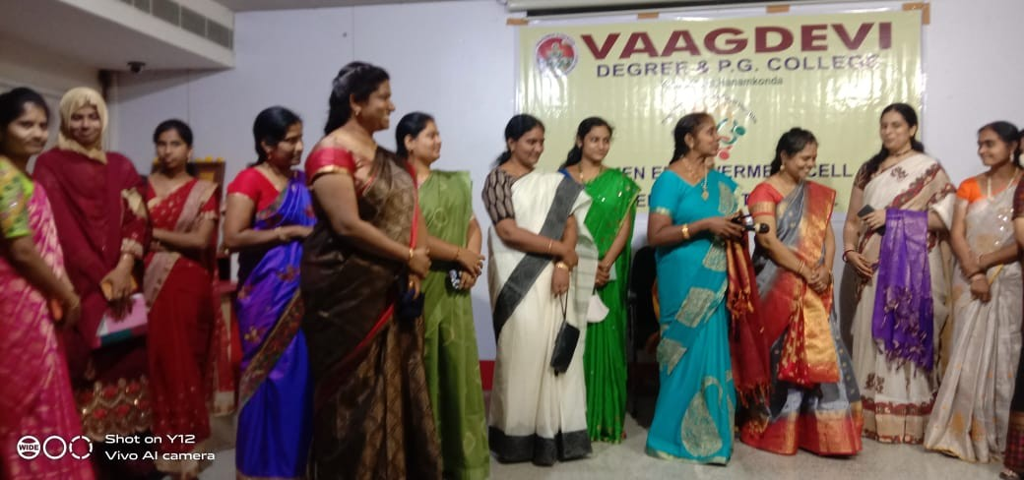

Woman Empowerment Celebrations on 8.3.2021

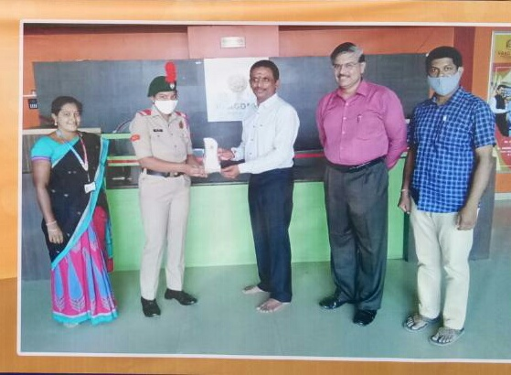

Special Achievement -student Ch. Bhargavi, BCA VI sem, Rank SUO was recognized and awarded the best cadet 8th Batallion.

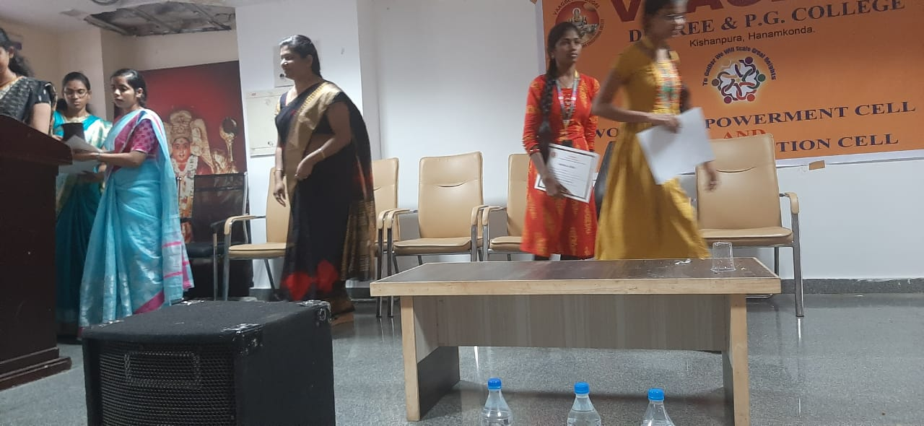

Students receiving certificates for various events conducted.

**Women Empowerment -Extension activities**

**Type of Activity** : Extension

**Title of Event**: Challenges faced by women in 21st century by Smt.T.Anusha

**Date**: 9.3.2021

**Name of organizing Departments**: Women Empowerment Cell & Women Protection Cell

**Names of coordinators**: Dr. C. Padmavati, Smt P. Rajitha, Ms K. Himabindu, T. Anusha

**Name & Designation of Resource persons**: : Co-ordinator, co-cordinators and member.

**Number of Participants**: 53 students

**Activity details**:

The committee initiated to organize a program to create awareness regarding gender sensitization with volunteers of the committee.

The students were asked to highlight the Challenges faced by women in 21st century.

A few of the issues were highlighted regarding Girl child like

* Infanticide is the killing of the child within a year of birth. This is mainly because the female baby is not given the respect due to her.
* Child marriage is performed as they believe that a daughter is a burden to the family. So they try to relieve that burden by marrying her at an early age.
* Women’s health is of paramount importance. However it is something which is being given the least importance. Only a healthy person can perform the routine duties and ensure that the family remains too remains nutritionally complete.
* Girl education is something which cannot be neglected as there is always a family who is dependent upon the girl. Only a educated mother can ensure scientific diet to a family in ensuring the nutritional requirements to be fulfilled.
* Gender issues are a common phenomena seen even in educated families.
* Beti bachao is a slogan mainly to ensure that the female fetus and the children are able to survive due to creation of awareness among the parents.
* Problems of females at work place were debated and discussed. This is something which females have to be careful about.
* Signatures were collected from visitors.

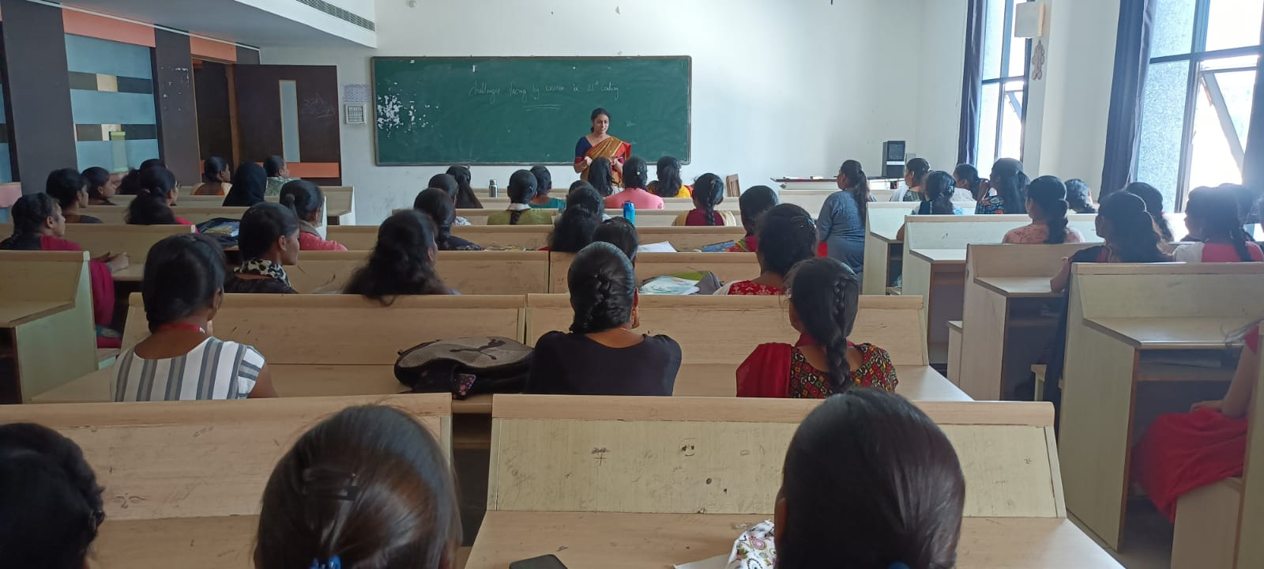

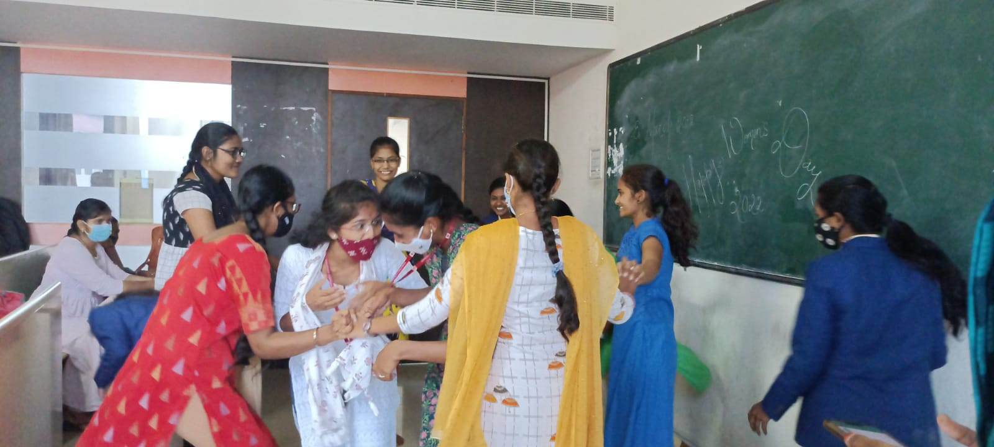

**Outcomes/Benefits:**

* The students came together in a platform exhibiting cooperation among themselves.
* They were able to understand the intricacies of the different problems.
* They opened up to express their viewpoints and high light various problems.
* Students played a skit to highlight the issues of women harassment.
* The skit played an important role in ensuring that the students understand the various problems.

**Academic Year 2019-2020**

|  |  |  |
| --- | --- | --- |
| Topic | Date | No. of participants |
| Gender Sensitization | 8.8.2019 | 43 |
| Self Defense training | 21.1.2020 | 350 |
| Developing Beauty skills to look Elegant. | 31.1.2020 | 150 |
| Legal Rights Awareness | 1.2.2020 | 210 |
| International Women’s Day | 8.3.2020 | 87 |

**1.Gender Sensitization:**

It is extremely important to ensure that students develop a feeling of Equality. It is extremely important to understand self worth to gain confidence. This becomes the prime source to create awareness among the girl students regarding the problems they can face in and around them. To encourage thinking ability and creativity among them. Dr. C. Padmavati enlightening the students about Gender sensitization.

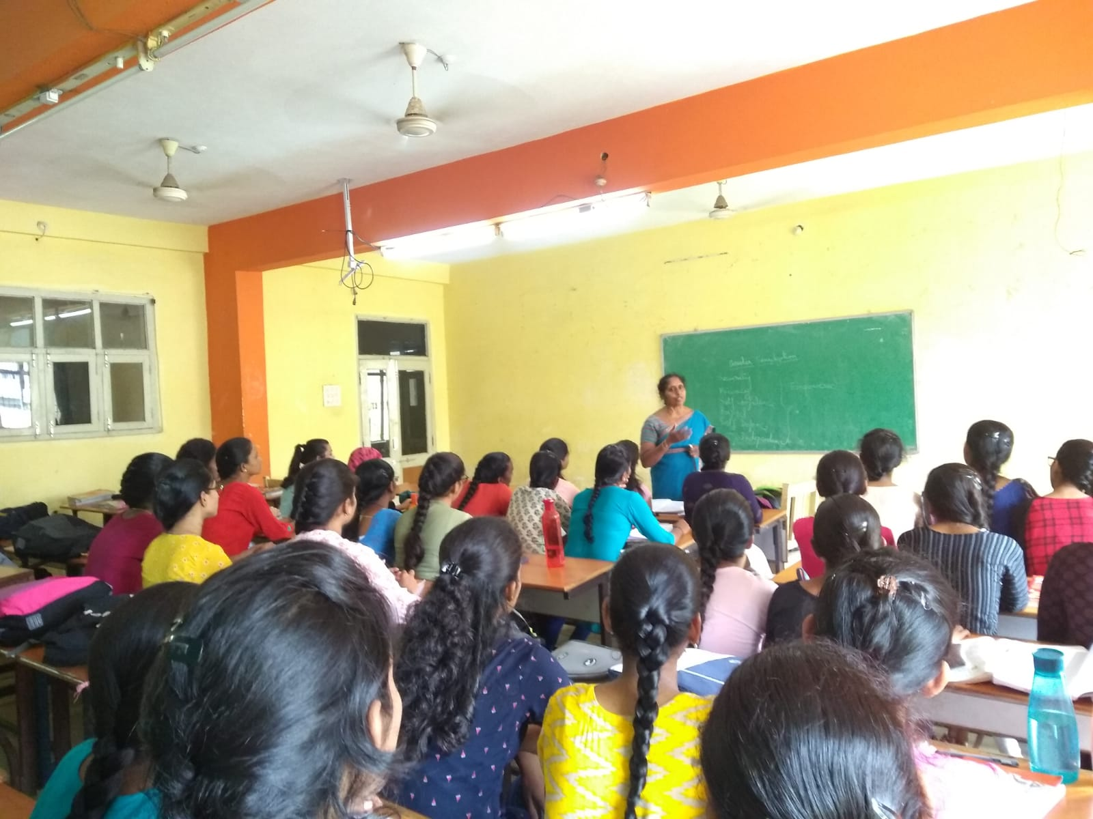

Dr. C. Padmavati On Gender sensitization.

**2.Self Defense Training:**

:

Self Defense classes were organized for the girl students of the entire college in different sessions on 21.1.2020. The Instructor was Sri Palakurthi Papaiah, Black belt V Dan. He demonstrated along with his student volunteers the benefit of learning self defense Techniques.

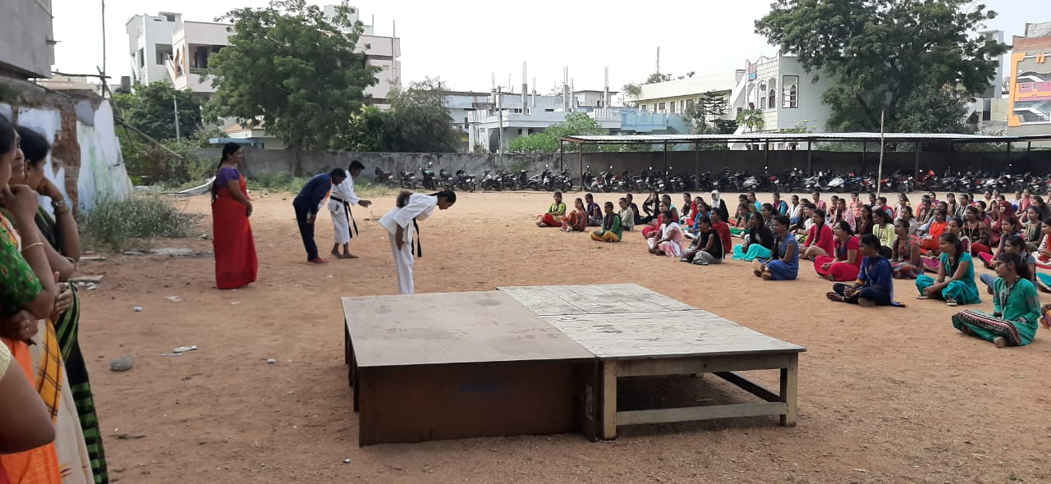

3.Women Empowerment -Extension activities

**Type of Activity**: Extension

**Title of event**: Developing Beauty skills to look Elegant.

**Date:31.1.2020**

**Name of organizing Departments**: Women Empowerment Cell & Women Protection Cell

**Names of coordinators**: Dr. C. Padmavati, Smt P. Rajitha, Ms K. Himabindu, Smt. R. Bhargavi

**Name & Designation of Resource persons**: Co-ordinator, co-cordinators and member.

**Number of Participants**:73 students

**Activity Details:**

* The participants were asked to see the demonstration of basic skills in cleansing and toning the skin.
* The finger movement and direction was highlighted.
* The basic techniques and tips required for applying make up was explained.
* The students were allowed to get hands on experience in basic techniques.
* Signatures were collected from the visitors.

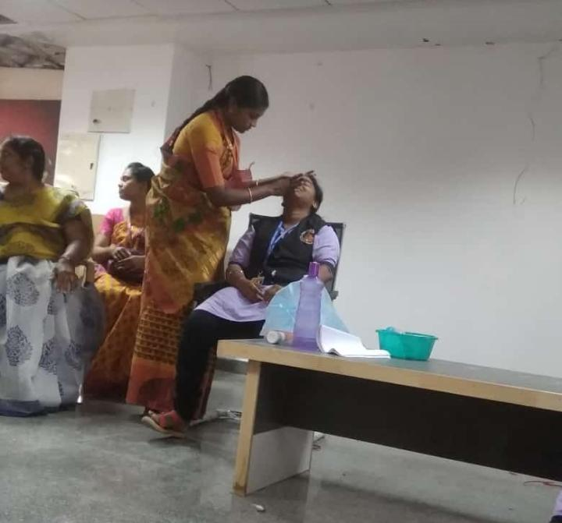

**Outcomes/Benefits:**

* The students were extremely excited to the prospectus of getting free basic knowledge regarding how to look elegant.
* They got the knowledge of beauty products available in the market and how to use them.
* This could act as the basic platform whereby the participants could enhance their basic knowledge and take it up as a scope for self-employment.

**Feedback Responses were taken**

**Participating certificates were given**

**4. Legal Rights Awareness:**

Prof. B. Vijayalakshmi addressed the girl students on Legal rights. She very clearly highlighted about the importance of Duties too. Her talk was very well received by the students. She patiently explained to the students their general behavior and how they tend to err. She emphasized on the fact that our attitudes too should change and we should not talk only about our rights.

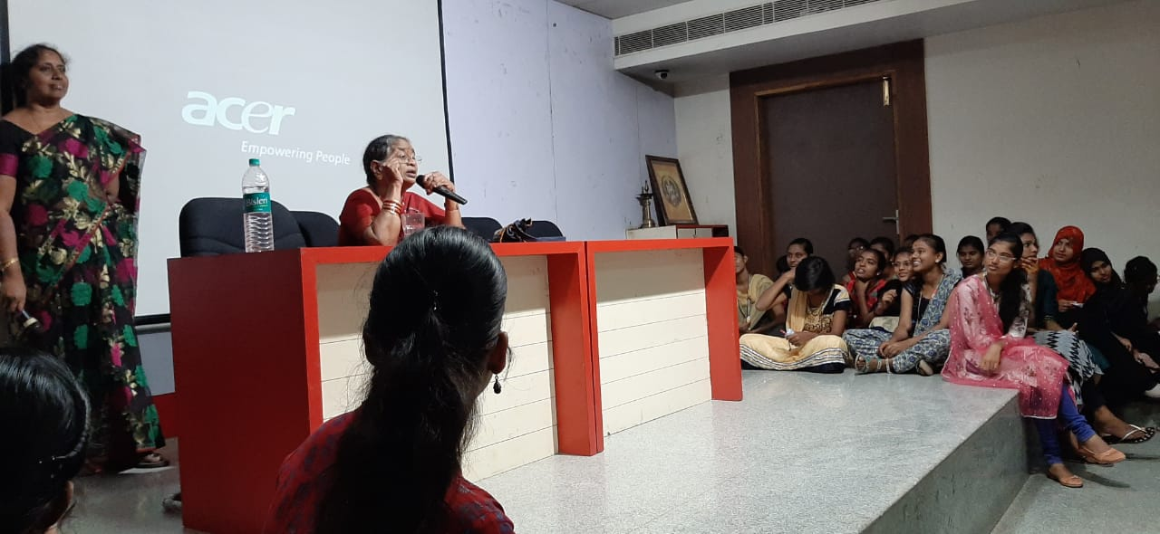

Prof B.VijayaLakshmi Former Principal of Law college addressing the girl students on ‘Rights of women as well as Duties’ on 1.2.2020.

**5.International Women’s Day:**

International Women’,s Day was celebrated on 8.3.2020.. The gathering observed a presentation on the Importance and challenges faced by the women. Important women achievers and exceptional student achievers were felicitated. The felicitations help other members to get motivated.

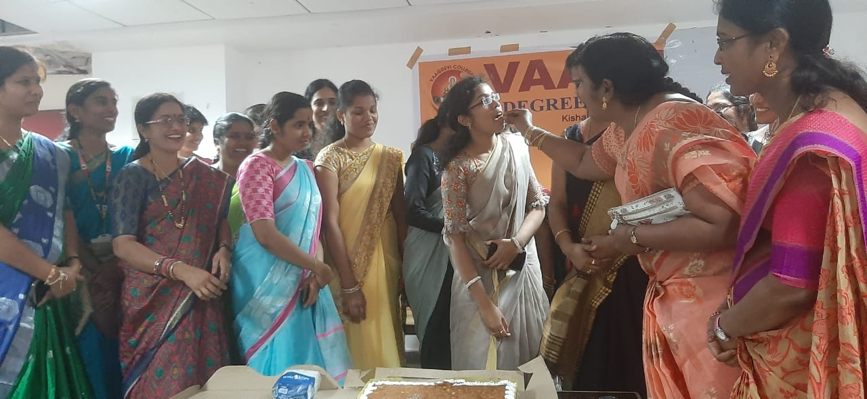

Women’s Day Celebration 8.3.2020

Lt. B. Sabitha achieved the best ANO award and was felicitated on the occasion of Women’s day. Smt. R. Bhargavi was felicitated for being the resource person for teaching about Beauty techniques, tips and beauty products for the benefit of young students.

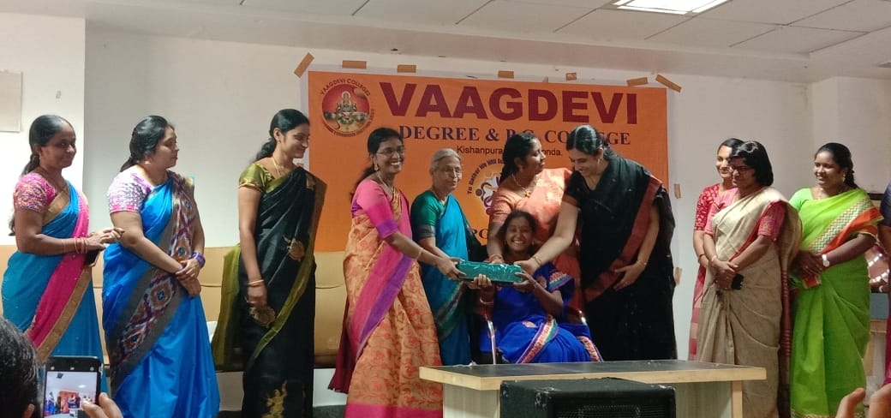

Congratulations Lt. B. Sabitha NCC officer on being awarded ‘BEST ANO AWARD’

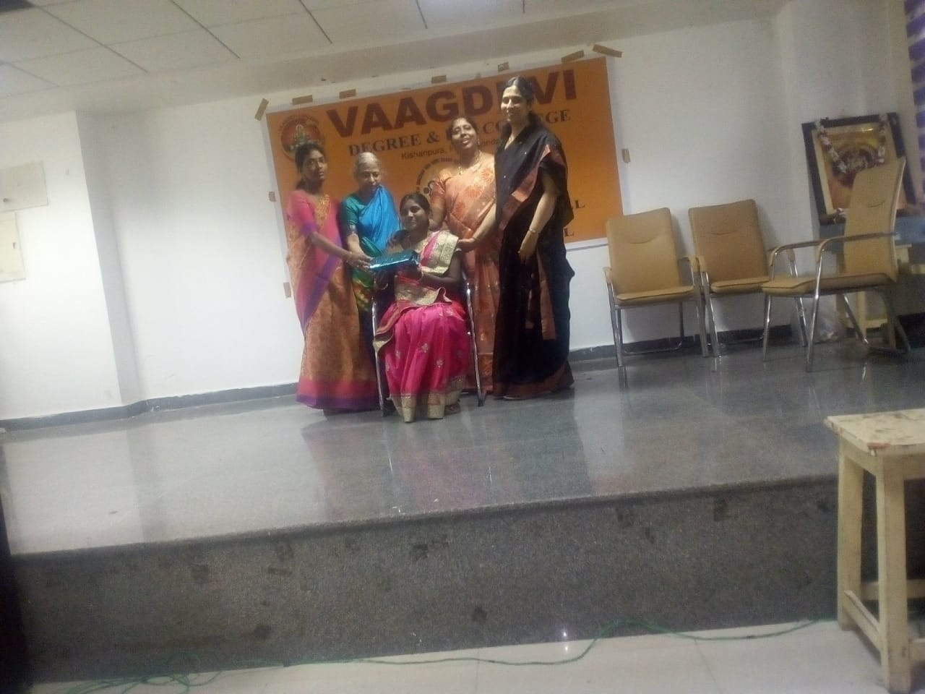

Special Thanks to our In House Resource Personnel Ms. R. Bhargavi on the occasion of Women’s Day

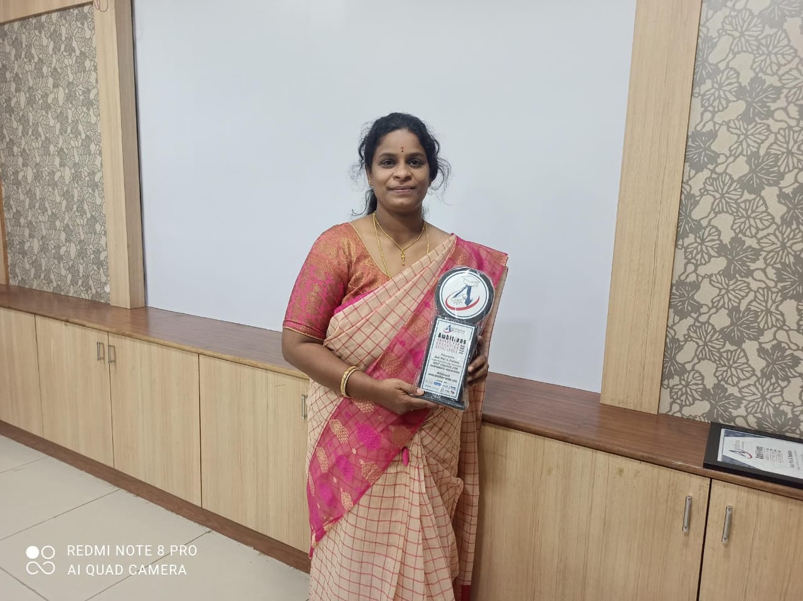

Smt. G. Pushkala Recipient of Best College for Corporate Relations 2020

**Academic Year 2018-2019**

|  |  |
| --- | --- |
| Self defense Training | 29.9.2018 |
| Silk Thread Embroidery | 9.11.2018 |
| Female feticide | 25.11.2018 |
| International Women Day | 8.3.2019 |

**1.Self Defence Training:**

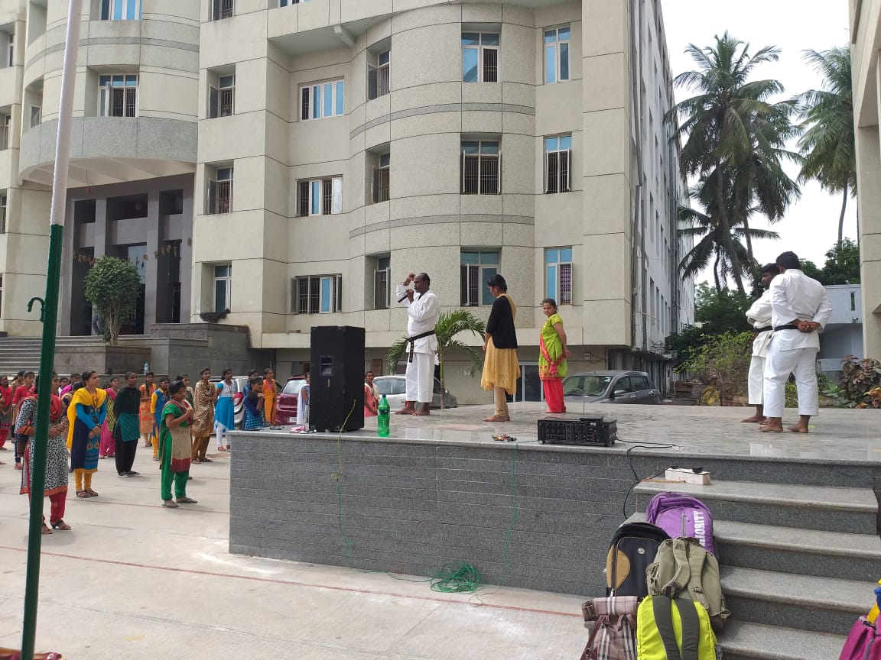

Reneshi Sreenu Babu racha

Mitsuya kai Hayashi-ha shitu Hyu karate-do India was the instructor. This program was conducted in September 2018.

He gave very nice suggestions to the girl students how to surprise the opponent and make them helpless. He gave very nice tips of weak places to hit and escape.

**2.Self Employment-Silk Thread Embroidery**

Our Internal Resource Personnel, Faculty in the Department of Languages-Sanskrit, Ms Pilamari Sunitha demonstrating under the series ‘Self Employment’, she has been teaching how to embroider using silk threads. Hand embroidery is a very sought after craft and is in great demand.

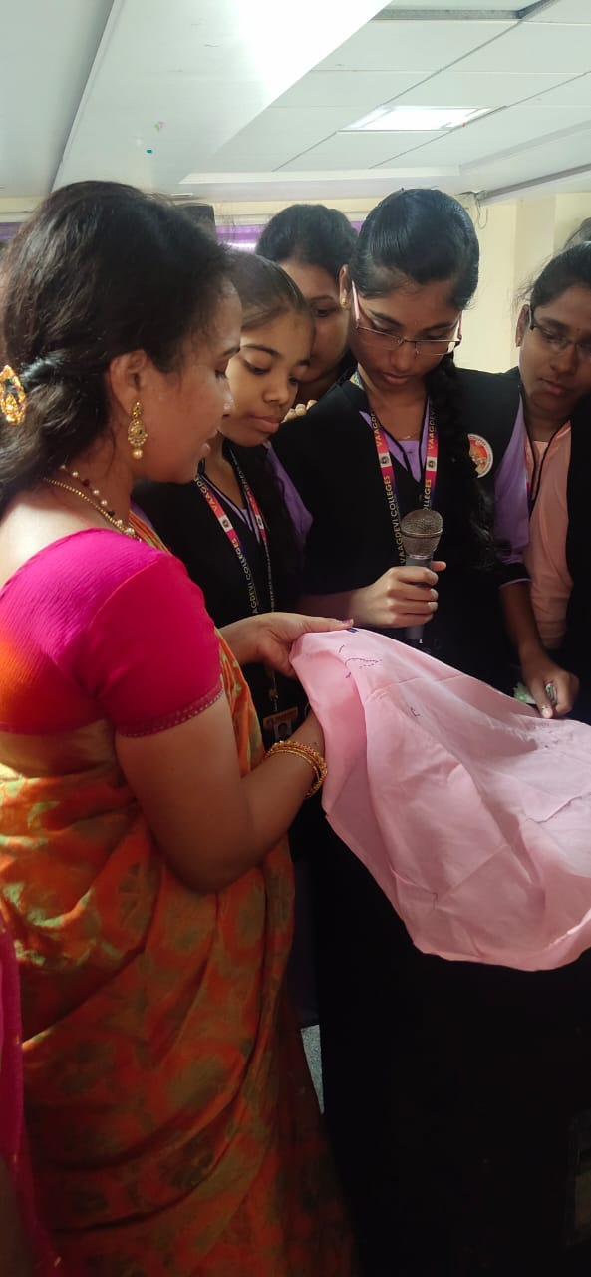

Ms Pilamari Sunitha demonstrating under the series ‘Self Employment’,

**3.Female feticide**

Female feticide in India is the abortion of a female fetus outside of legal methods. A natural sex ratio is assumed to be between 103 and 107 males per 100 females at any number above it is considered suggestive of female feticide. The child sex ratio is between the normal natural range in all eastern and southern states of India. Significantly higher in certain western and particularly north-western states. Female feticide is a gender selective abortion where a female fetus is illegally terminated solely based on the reason that the fetus is a girl.

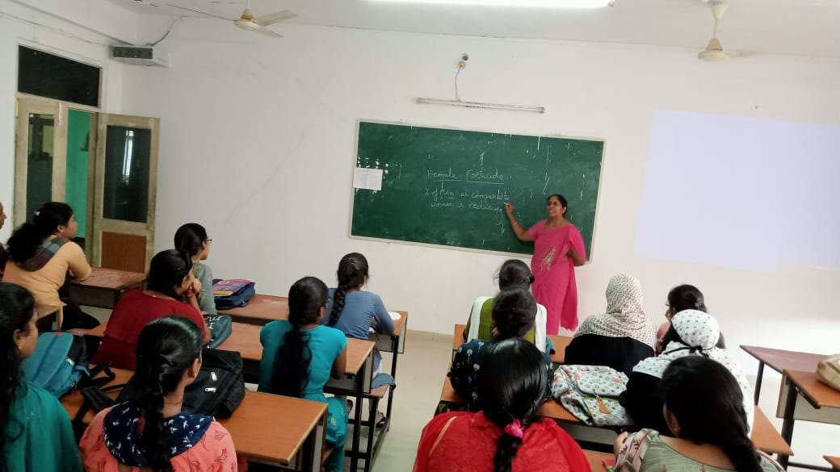

The gravity of Female feticide by Dr. C. Padmavati

4.Women’s Day 2019:

Women’s Day 2019 was celebrated in presence of all women in the campus. Each Department planned different activities. Chemistry, English, Microbiology, Zoology Departments performed Dance. Others planned games from their departments.

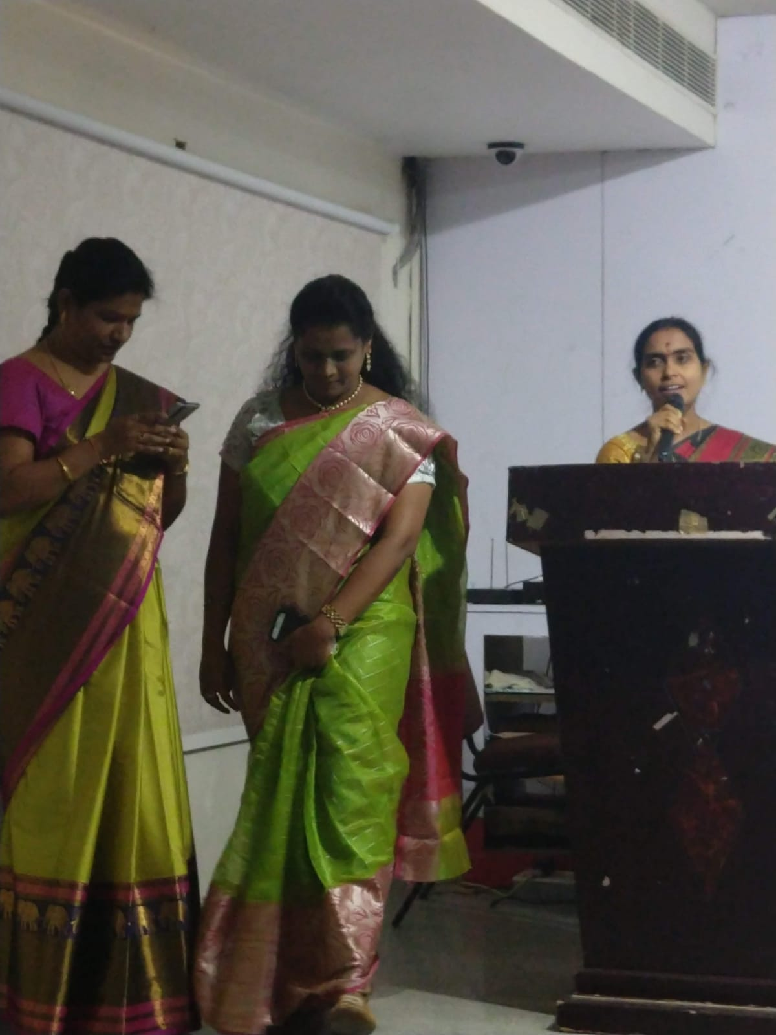

Women’s day celebrations 2019

**Academic Calendar 2017-2018**

|  |  |
| --- | --- |
| Legal rights of women | 23.9.2017 |
| Nirbhaya Act 2013 | 4.11.2017 |
| Anti sexual Harassment Act | 9.12.2017 |
| Beti Bachao Beti Padhao | 8.2.2018 |
| International women’s Day | 8.3.2018 |

**1.Legal Rights for women:**

Dr. Vijayachander highlighted the common problems encountered by women. It is very important that women know how to address their problems. They should develop self-confidence so as to be able to face the problems that they encounter. The awareness of the Law helps them in becoming empowered. It also becomes an important weapon to seek redressal.

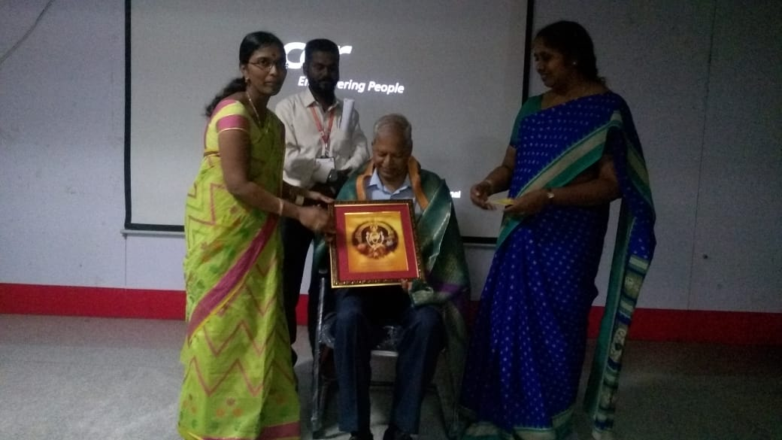

Prof. Vijaychander, Former Professor in Law, addressing the students on ‘Legal rights for women” on 23.9.2017

**2.Nirbhaya Act 2013:**

2012 Delhi gang rape and murder case involved a rape and fatal assault that occurred on 15 december 2012 in Munirka neighbourhood south-west Delhi. The incident took place when Jyothi Singh a 22 years old physiotherapy intern was beaten gang-raped and tortured in a private bus in which she was travelling with her male friend. There were 6 others in the bus including the driver, all of whom raped the woman and beat her friend. This was implementedin 2013. Under its purview acid attack, sexual harassment stalking trafficking of person are included. 4.11.2017

**3.Anti Sexual Harassment Act 2013:**

An act to provide protection against sexual harassment of women at workplace and for the prevention and redressal of complaints of sexual harassment and for matters connected therewith or incidental thereto. 9.12.2017

**4.Self employment -Thread jewellery**

Our Internal Resource Personnel, Faculty in the Department of Chemistry, Ms Salma Gayathri demonstrating under the series ‘Self Employment’, she has been teaching how to make thread jewellery. Followed by the finished product. This product is a craze among youngsters who use them during marriages and other special occasions as a matching to their dresses. They are ready to buy them at exorbitant rates. However, the raw materials are cheap and it can be a profitable small scale business venture. It can be done from home itself without much investment.

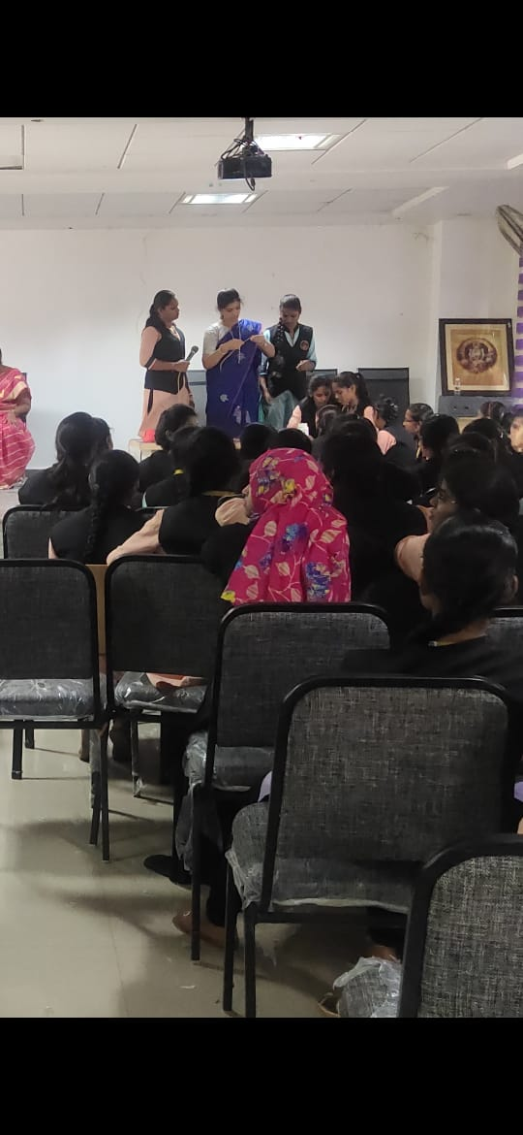 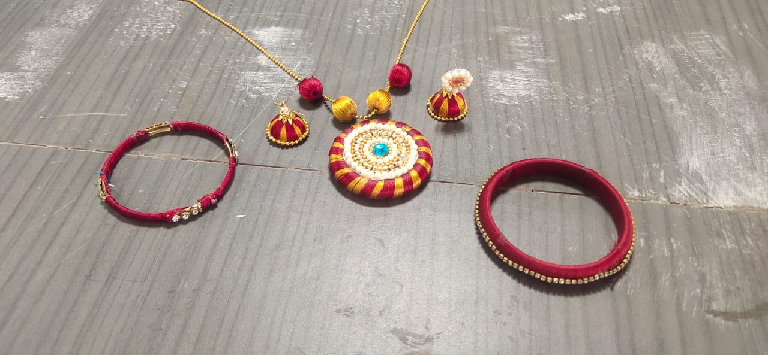

**5.Women’s day celebrations 2018**

Women’s day celebrations are conducted with lot of activities lined up for the day. All the female staff in the campus including Iv class employees join under one roof and celebrate the day.

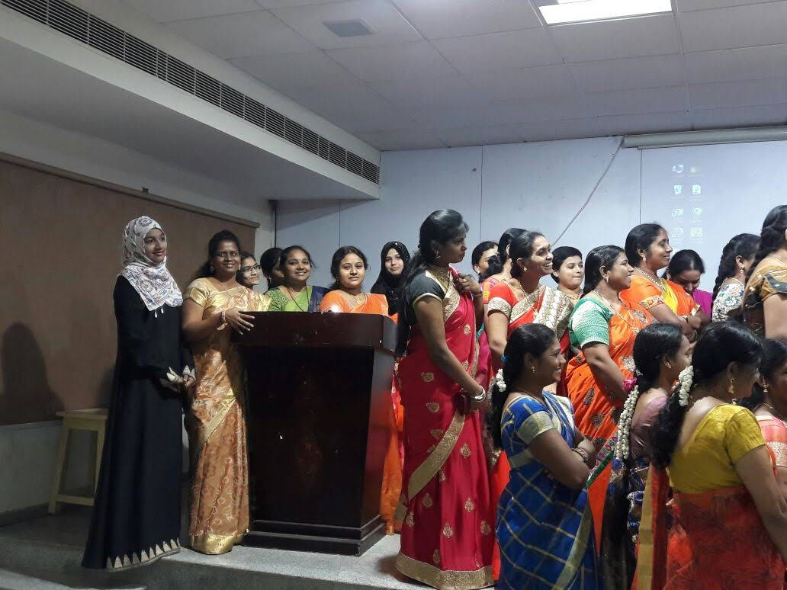

Women’s Day Celebrations 8.3.2018

**Academic Year 2016-2017**

|  |
| --- |
| She Team activity  ACP-Puja |
| Legal awareness-Prof. Padma |
| Quiz-Legal awareness |
| Elocution-Dowry Prohibition |
| Debate Domestic violence |
| Women’s day celebrations |

**1.She Team activity -ACP-Puja**

ACP Puja was in our campus giving suggestions regarding the various protective measures students should take. She is a very versatile speaker who was giving suggestions as to how to beware about strangers and take care of themselves. An extremely experienced speaker she was quoting from her experience and gave a number of case studies as an example to drive home her point.

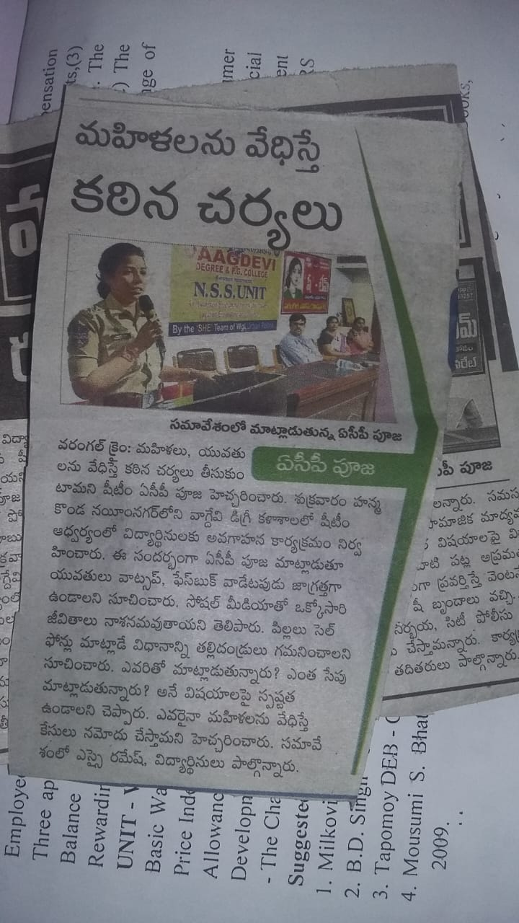 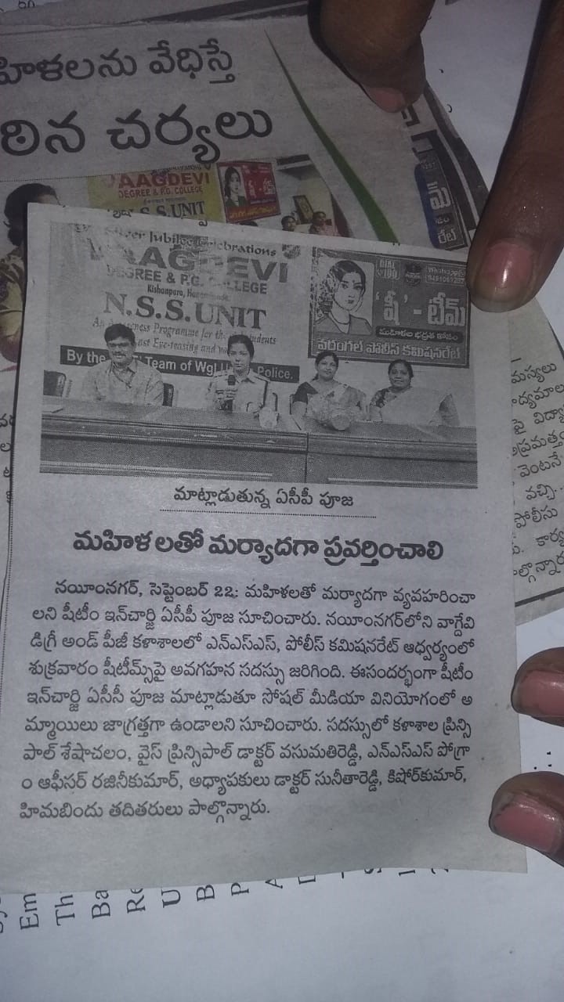

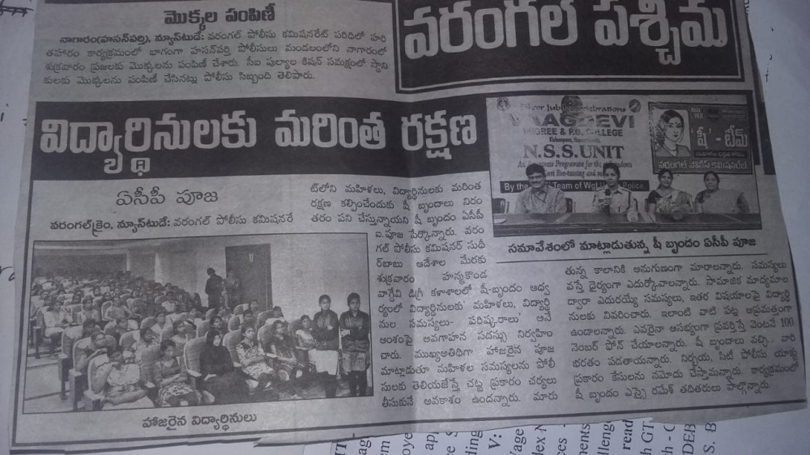

**2.Legal Awareness****:** Prof. Padma presented a lecture on Legal Awareness for the benefit of students and faculty. Women have to know their rights. She spoke extensively on Domestic violence. and Dowry Prohibition and the laws related to them. To emphasize on this point, a quiz competition too was conducted to assess the students. Moreover Elocution competition was conducted on Dowry prohibition and Debate competition as conducted on Domestic violence. An extremely experienced Lawyer in teaching profession, her talk was extremely inspirational and motivating to the students.

**3. Student competitions**

**Domestic Violence Act 2005** is the protection of women from domestic violence. It includes Physical violence, other forms of violence such as emotional and psychological abuse. Women form the largest group of victims of domestic violence, since time immemorial and violence against women still continue even in the 21st century. Domestic violence is not just limited to women, men , children and elderly people can also be victims of it.

**Dowry Prohibition act 1986,** an act to prohibit the giving or taking of dowry that is any property or valuable security given or agreed to be given either directly or indirectly by any party of parents of either side at the time of marriage, or before or after the marriage ceremony.

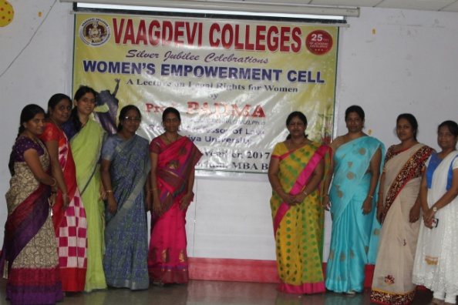

.

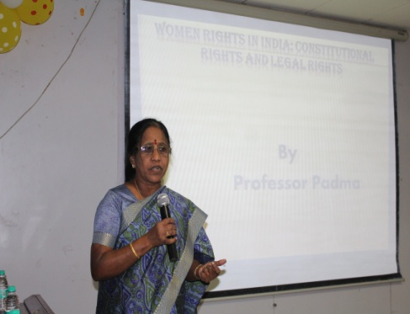

R

LAL NEHRU

**Prof Padma Delivering her lecture**

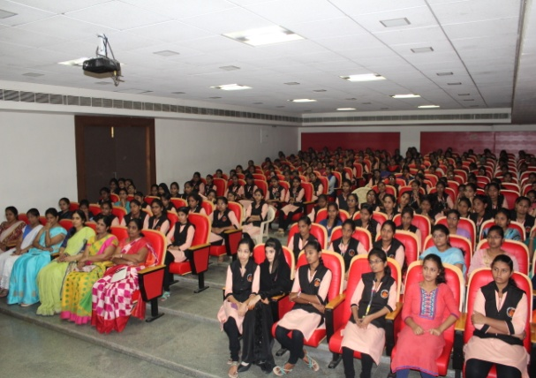

**Students listening keenly**

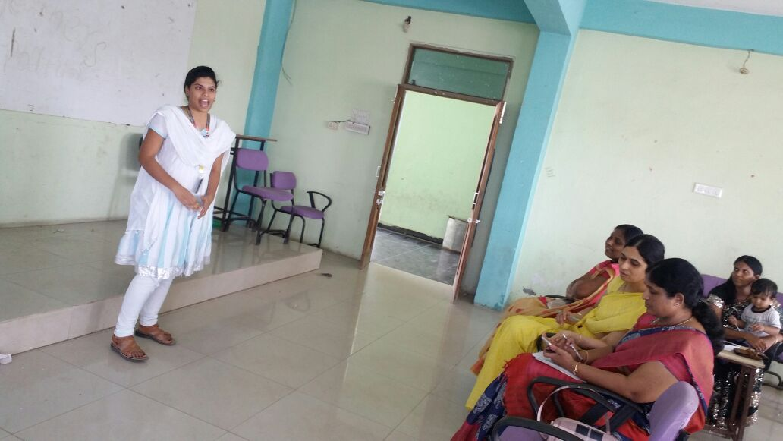Student activities conducted based on the talk delivered by Dr. Padma 6.2.2017

**Debate on Domestic Violence 2017**

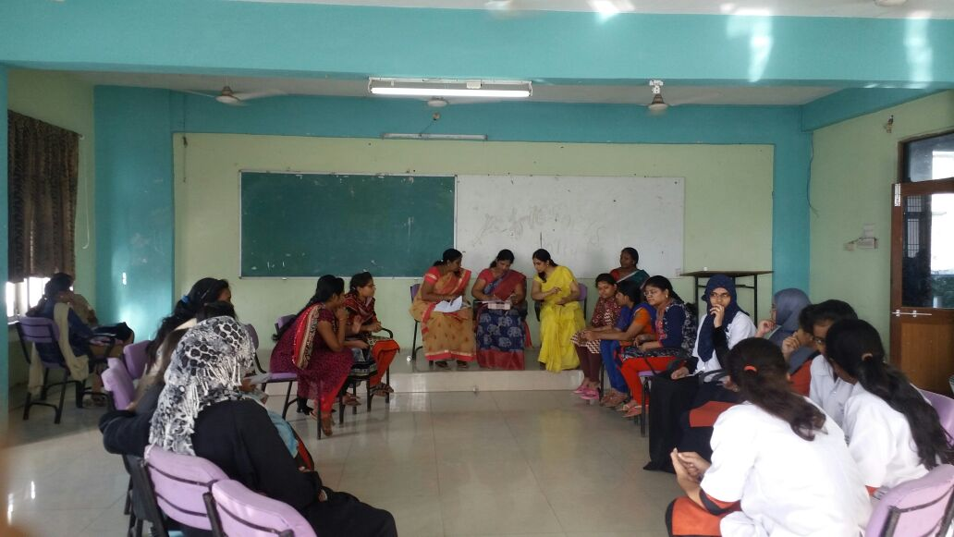

Elocution On Dowry Prohibition act

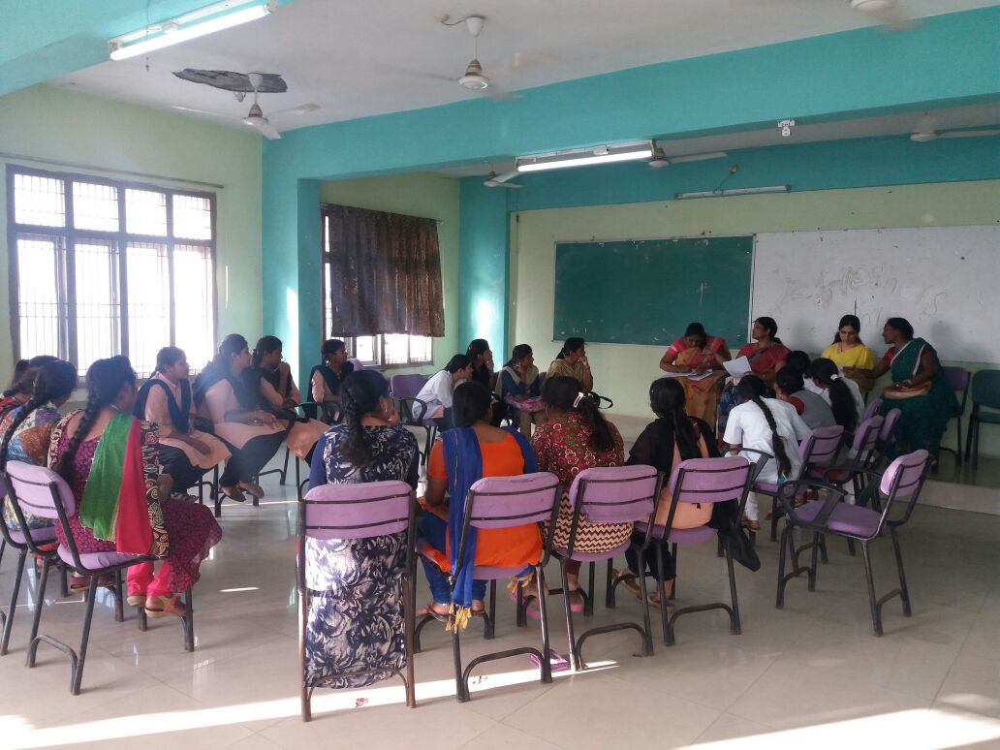

Quiz competition on Legal awareness

Women’s day 2017

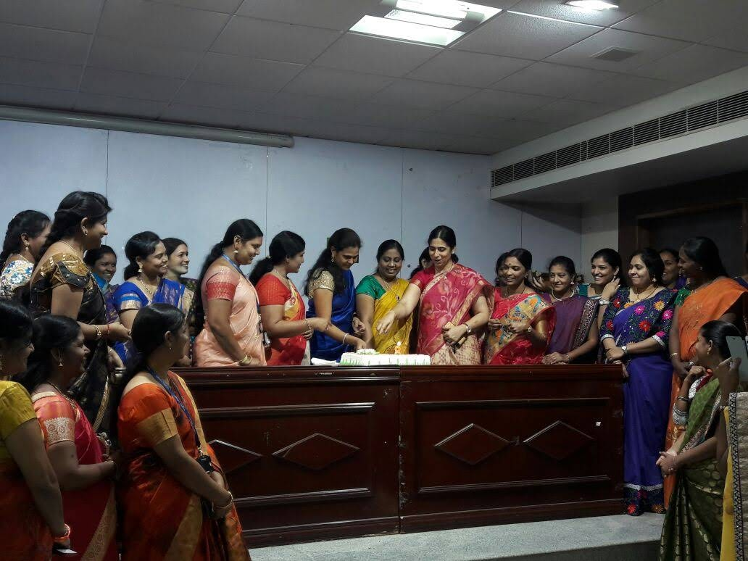

Women’s day celebrations were conducted on 8.3. 2017. Smt Ch. Vahini Devi Director was the chief guest.

**Counselling/Mentoring:**

To boost the morale of the students, we firmly believe that constant interactions are essential. To achieve this, we have been following Mentorship, which helps mold and motivate the students. Understand the social and mental background of the student. To provide adequate support to the student to excel in academics. To extend laboratory/Library/ICT facilities to all sections of the students. To hear and address the students' complaints, necessities, and grievances.

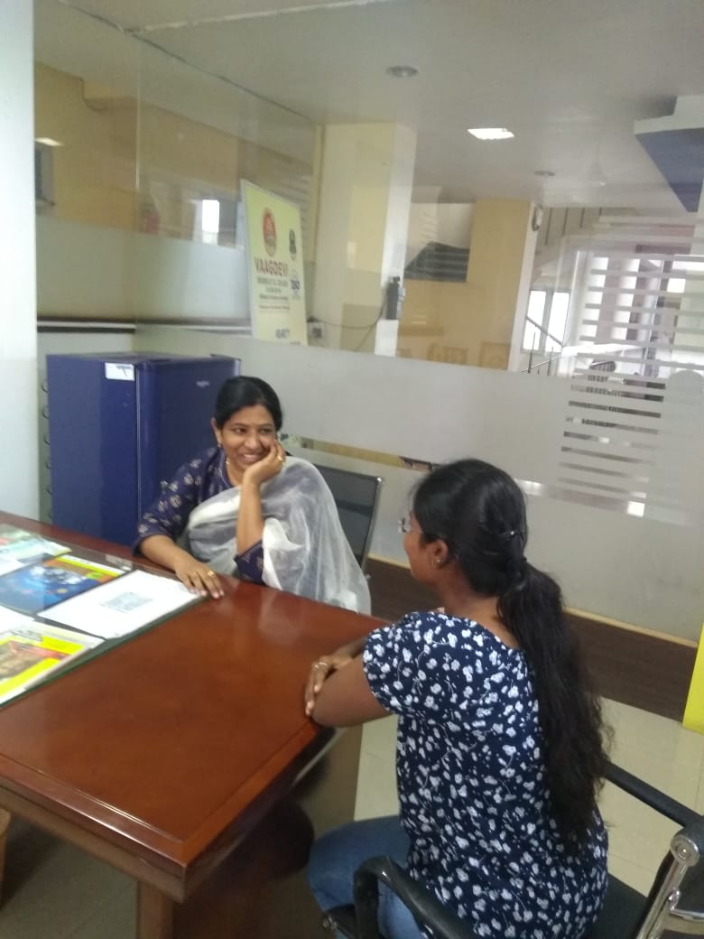

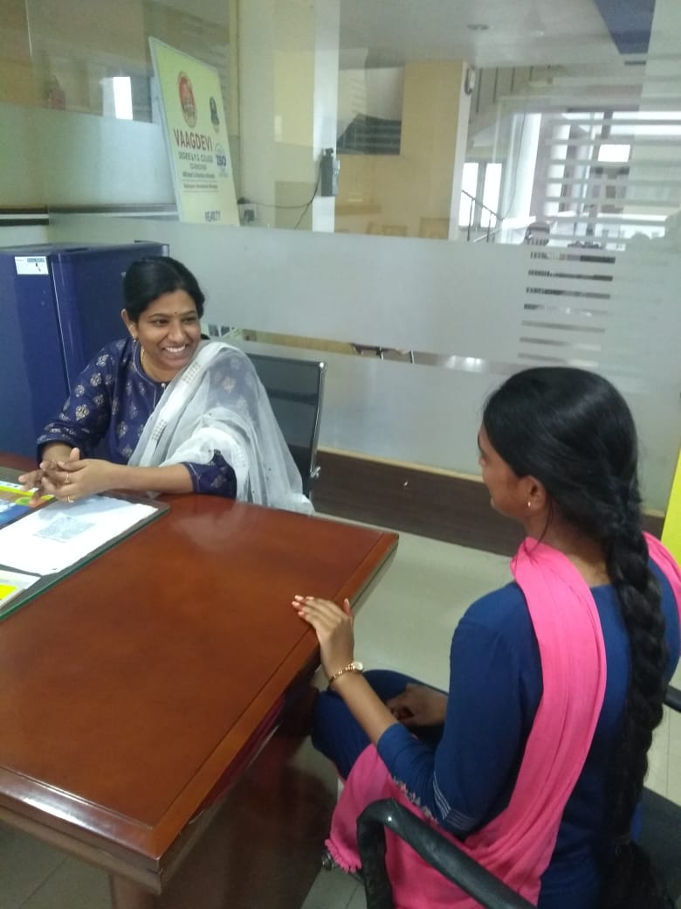

**Bathukamma:**

Bathukamma is a state festival of Telangana. This is celebrated every year in the campus. The Amavasya day before beginning of Vijayadashami festivities, is the day when Bathukamma begins. It is also known as chinna bathukamma. The flowers are arranged in the morning, followed by puja and the offering of naivadyam. In the evening, women gather near water beds, sing, dance and distribute naivadyam, turmeric, and Kumkum. The flowers are left after playing in the temple premises. Naivaidyam usually comprises of different flours of cereals, pulses mixed with jaggery/sugar. The culmination day is the Ashtami. On that day the flowers are immersed in water. The entire festival is a feast to the eye. The flowers used have been found to have antimicrobial properties.

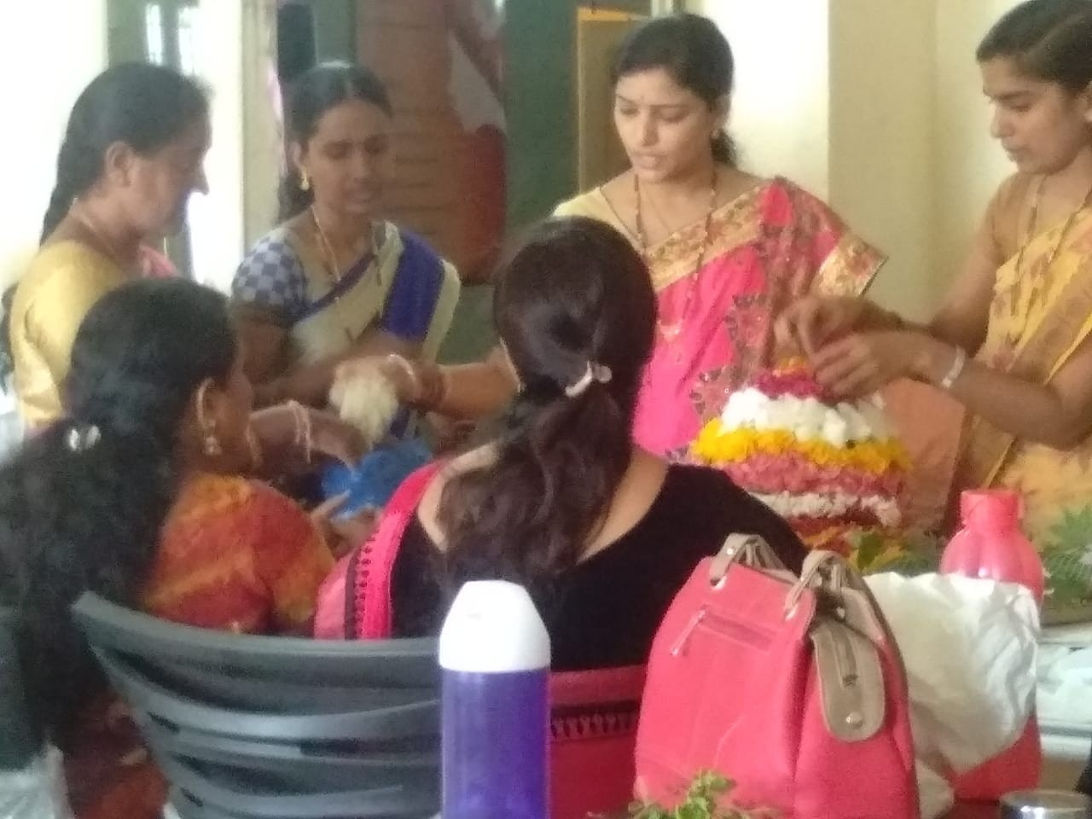

Beginning of preparation of Bathukamma

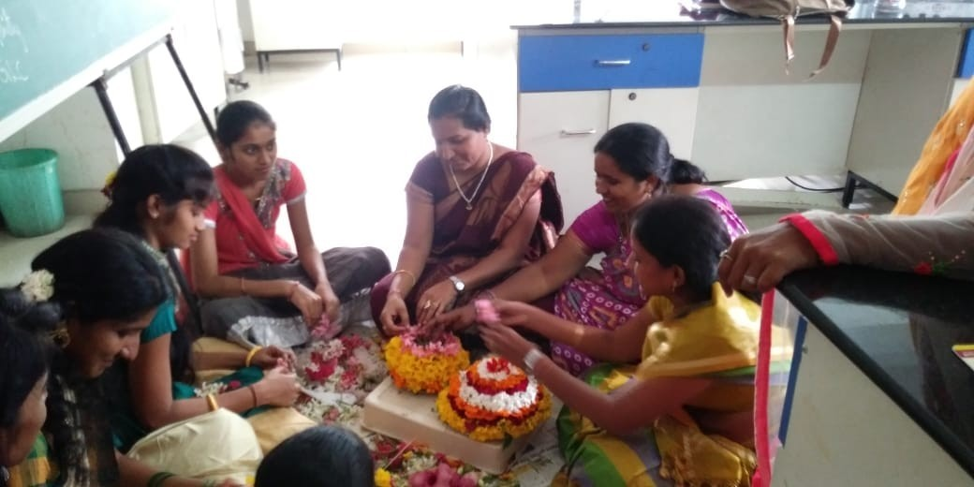

Layers of flowers and leaves are accumulated on a firm base.

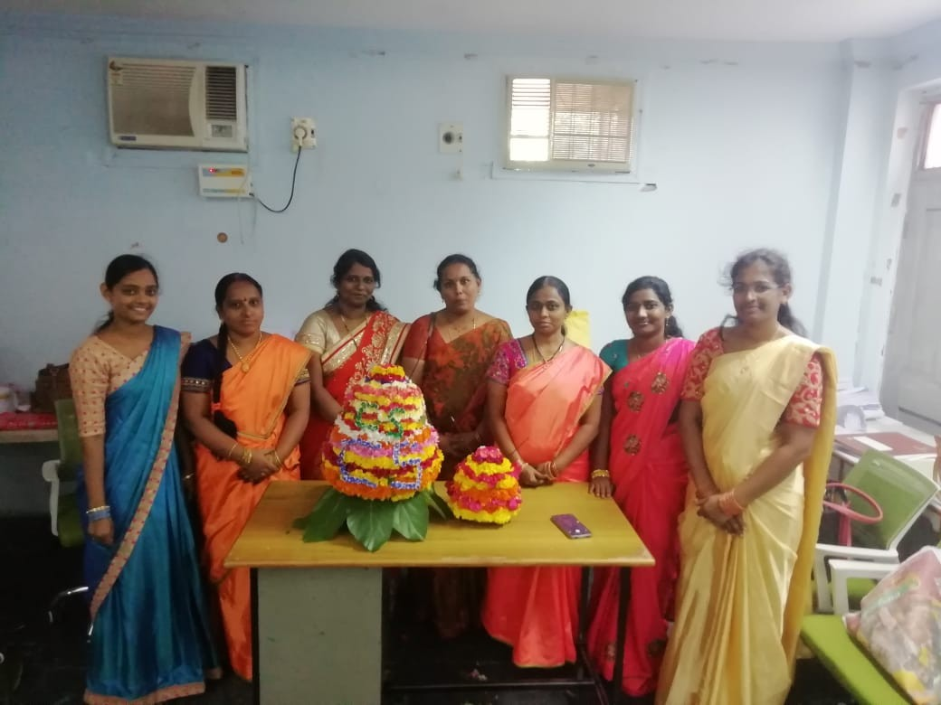

Completion Of Formation of Pedda Bathukamma and Chinna Bathukamma

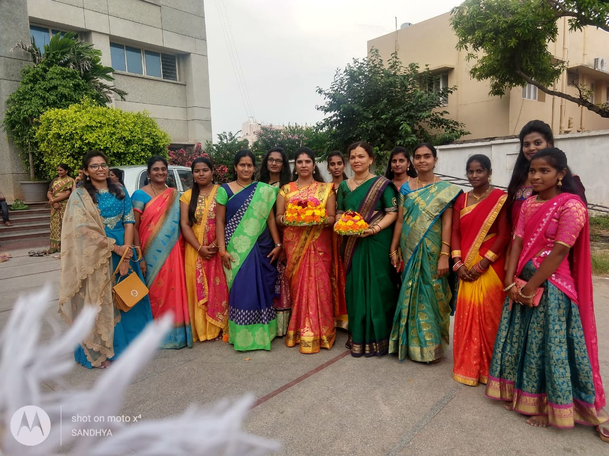

**Coming to join and form a gathering**

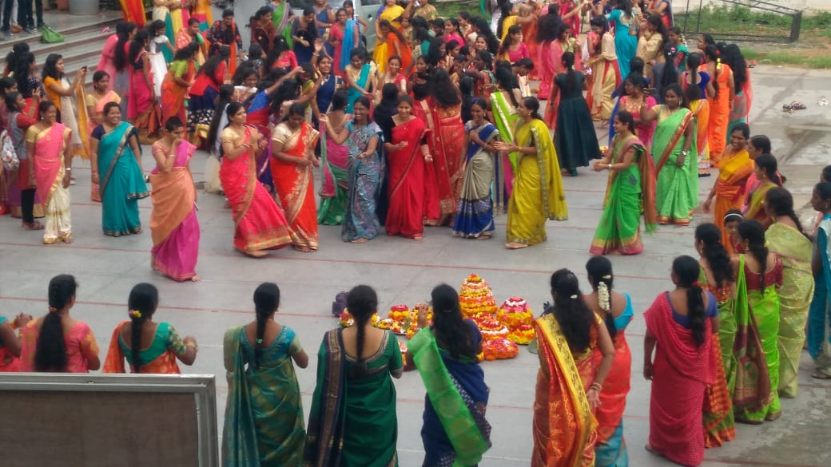

**Rhythmic singing and dancing around bathukamma**

**The songs sung for bathukamma are special and unique only for this occasion. The lyrics are extremely meaningful and depict the culture and traditions of the Telengana state. The prasadam are made with rice, sesame, groundnut, Copra, lentils, pulihora, curd rice, fruits etc.**